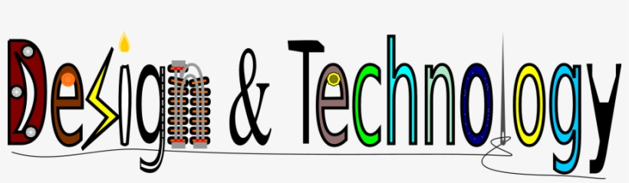

At Keelham Primary School

Intent
Design and technology is an inspiring, rigorous and practical subject. Design and Technology is about providing opportunities for children to develop their capability. By combining their design and making skills with knowledge and understanding they learn to create quality products. We bring learning to life at Keelham. Using creativity and imagination, our pupils at Keelham evaluate and investigate existing products, design and make products that solve real and relevant problems, hypothesis and key enquiry questions within a variety of contexts, considering their own and others’ needs, wants and values. Fundamentals Knowledge of DT and skills are taught progressively and revisited prior to new learning to develop understanding.

Implementation

At Keelham, children embed their skills and develop knowledge through a wide range of creative sessions which are differentiated to meet all needs including: researching and investigating similar products and techniques. Children will design to a brief independently. Throughout the sequence of learning, our children will apply new techniques to fasten, cut, strengthen and present using a wider range of materials including; cardboard, fabric, plastic and wood and learn how to use tools safely. Using subject specific vocabulary, children will be encouraged to evaluate work of designers and work of their own.

Communication and co-operation are also essential aspects of the DT learning sequence. There is continuous formative assessment during the learning sequence. Children are involved in the overall assessment of the finished piece of work by evaluating the making, ideas and knowledge used.

We ensure that we follow the National Curriculum areas of knowledge:

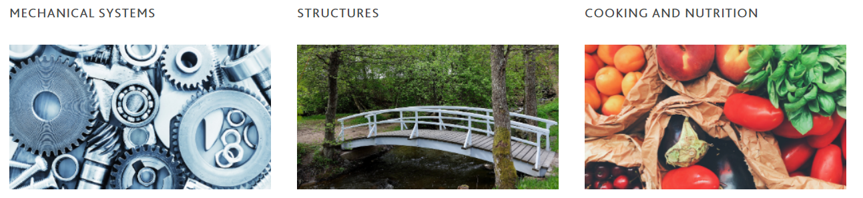

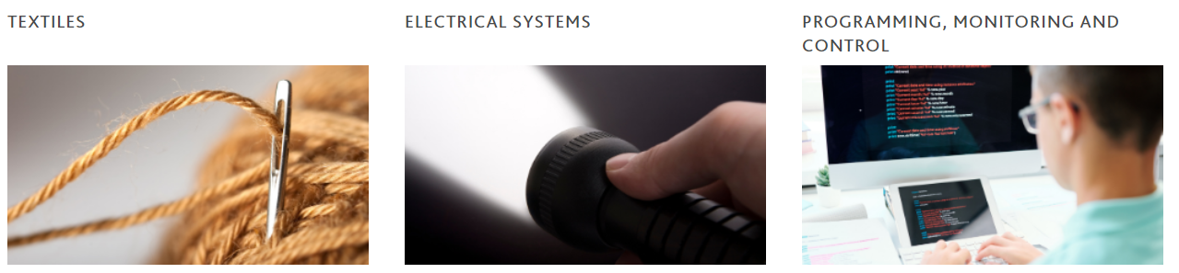
Whole School Curriculum Mapping 2021-22
Year Group | Autumn |  | Spring |  | Summer
Foundation | 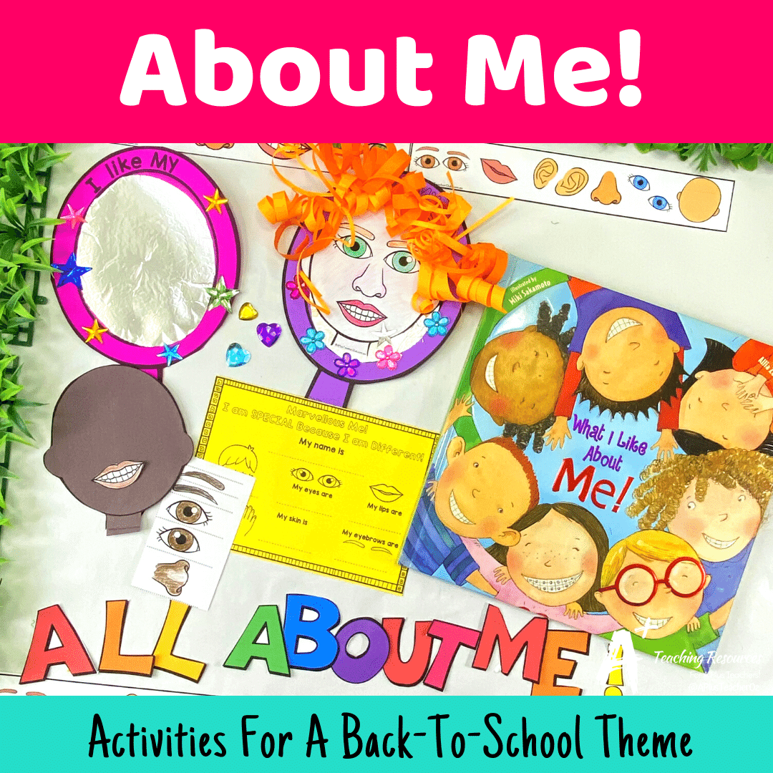 | 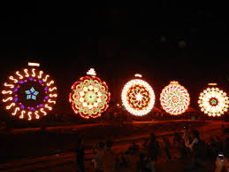 |  |  | 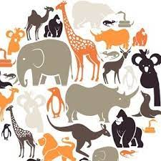
Focus | All about me | Festivals of Light | Winter Wonderland | Real life Superheroes | All creatures great and small | A safe and healthy me
Coverage | - Explore different materials and tools.  - Use one-handed tools and equipment, for example, making snips in paper with scissors.  - Use a comfortable grip with good control when holding pens and pencils.  - Show a preference for a dominant hand.  - Explore collections of materials with similar and/or different properties.  - Explore different materials, using all their senses to investigate them. Manipulate and play with different materials.  - Join different materials and explore different textures.  - Explore colour and colour mixing |  | - Develop manipulation and control.  - Develop their small motor skills so that they can use a range of tools competently, safely and confidently. Suggested tools: pencils for drawing and writing, paintbrushes, scissors.  - After close observation, draw pictures of the natural world, including animals and plants.  - Make simple models which express their ideas.  - Draw with increasing complexity and detail, such as representing a face with a circle and including details. |  | - Talk about the differences between materials and changes they notice.  - Explore how different materials sink and float.  - After close observation, draw pictures of the natural world, including animals and plants.  - Develop their own ideas and then decide which materials to use to express them.  - Return to and build on their previous learning, refining ideas and developing their ability to represent them.
Year 1/2 | 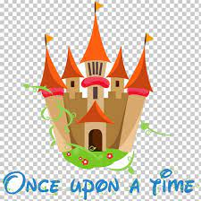
Key Question/Problem |  |  | Zoom to the Moon and Beyond
Coverage | Healthy Eating including Senses  - •Make porridge for 3 bears in Goldilocks  - •Investigate different types of bread including gingerbread (Hansel and Gretel)  - •Cakes and buns for Grandma (Little Red Riding Hood)  - •Smell/taste pots  Design and make tasks (See science links)  - •Design a house safe for the 3 little pigs. Compare and contrast different materials and best uses  - •Build a beanstalk for Jack (Link to science)  - •Design a safe way for Little Red Riding Hood to get through the forest  - •Design and make a new chair for Baby Bear in Goldilocks and the 3 bears  - •Design and build a bed for Princess that she can sleep comfortably. |  | - Wheels and axles  - Design a vehicle that moves  - Investigate wheels and axles  - Investigate rockets |  | - •Sculpture using natural materials like twigs, branches and clay  - •Paper sculpture of animals  - •Investigating all the parts of a flower by unpicking the flower
Year 3/4 | 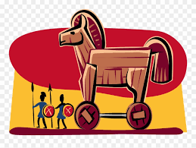 |  | 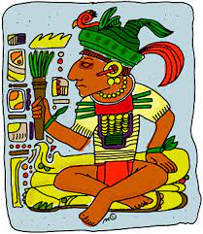 |  | 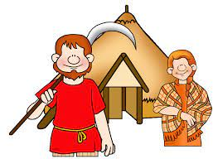  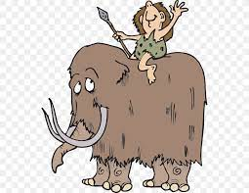
Key Question/Problem | It’s all-out War! |  | Surviving the Biomes |  | Hunters, Gatherers,  Invaders & Settlers
 | - Design a Trojan horse to fit Lego soldiers into using our learning to inform.  - Create annotated sketches.  - Make using a selection of materials.  - Evaluate their design and effectiveness. |  | - Make a traditional Maya hot chocolate recipe.  - Compare to modern day and links to diet.  - Make a range of buildings that you can put together to make a Maya city. |  | - Design clothing for a man/woman who lived in the Stone Age and Iron Age.  - Compare designs and why they may be similar/different.
Year 5/6 | 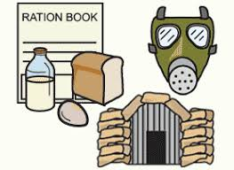 |  |  |  | 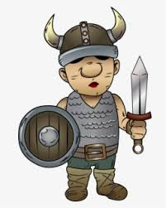
Key Question/Problem | It’s all-out War! |  | Surviving the Biomes |  | Hunters, Gatherers,  Invaders & Settlers
 | - Design a make an Anderson shelter ·  - Home front rationing recipes ·  - Design and create a working periscope  - Make do and Mend – learn how to darn a sock ·  - Make a Home Guard helmet |  | - Design and construct an igloo  - Design and create a variety of African instruments  - Adinkra printing onto fabrics  - Create savannah collages using different material |  | · Plan, design and construct a Viking longboat  Design and make an Anglo-Saxon and Viking shield  To design and create a piece of embroidery that tells a story (Bayeux Tapestry)

Design Technology
What makes a good DT unit of learning? |  | Pose an overall problem for your pupils to overcome…
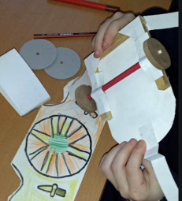  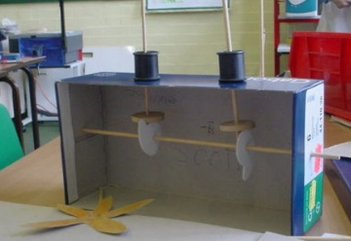  D&T involves thinking about what products are used for and the needs of those who use them. You must ensure that your unit is relevant by linking the activity to pupils’ interests, establishing real contexts for their work, and building upon their knowledge and skills in other subjects.  A good D&T activity has to have sufficient depth and breadth to enable pupils to learn practical skills and provide them with the knowledge to make products that move/ light up/ are structurally sound and do not collapse/ are safe and healthy.  Pupils need to be able to test, refine and develop the products they design and make to check that they work and improve them if they do not.  DT is a perfect opportunity to ensure that our pupils are global citizens of the future in an ever-changing world. |  | Pupils enjoy developing practical skills and make good progress in developing knowledge and understanding about the properties of materials when they have specific problems or challenges to solve. Examples of this:  - A moving vehicle for a driver to carry an egg safely across uneven ground  - A shelter for your playground to protect younger children from the sun  - Refreshing drinks for your class picnic.  Posing a problem that is thematic to your curriculum will fire up enthusiasm for the subject. Examples of this:  - Create a circuit to power a lighthouse from a sustainable power source  - Explore reasons behind Roman shield designs  - How does the structure of a Mayan temple link to the Mayan religion?
 |  | Questioning
 |  | Use questioning to encourage your pupils to prompt pupils to think through the problems they might encounter and to share their strategies to solve them.
Teacher Pedagogy links: | Tips to ensure effective practice
- Use existing products to inspire your pupils – these will help support their investigations, testing and analysis.
- Model your own ideas to your pupils. Model how you have made the product, and explain the methods you have used to tackle the investigations. This will help pupils talk about their ideas.
- Model the use of technical language and subject specific terms accurately to pupils.
- Use a range of resources, including computing control (ICT), electrical systems to allow pupils to flourish and overcome barriers.
- Pupils know and can clearly articulate what is expected of them at the beginning of each lesson.
- Pupils are always productive!

Impact
Children have the knowledge and skills to work confidently with a wide range of materials and begin working like a designer. Children make sustained progress in design technology and are ready to build upon their knowledge when they begin key stage 3. Children have the understanding of how the skills they are being taught can be used in a real life context. Children acquire a broad range of subject knowledge and draw on disciplines such as mathematics, science, engineering, computing and art. Children become global citizens of the future.

