Pupil Premium Strategy

2021-22

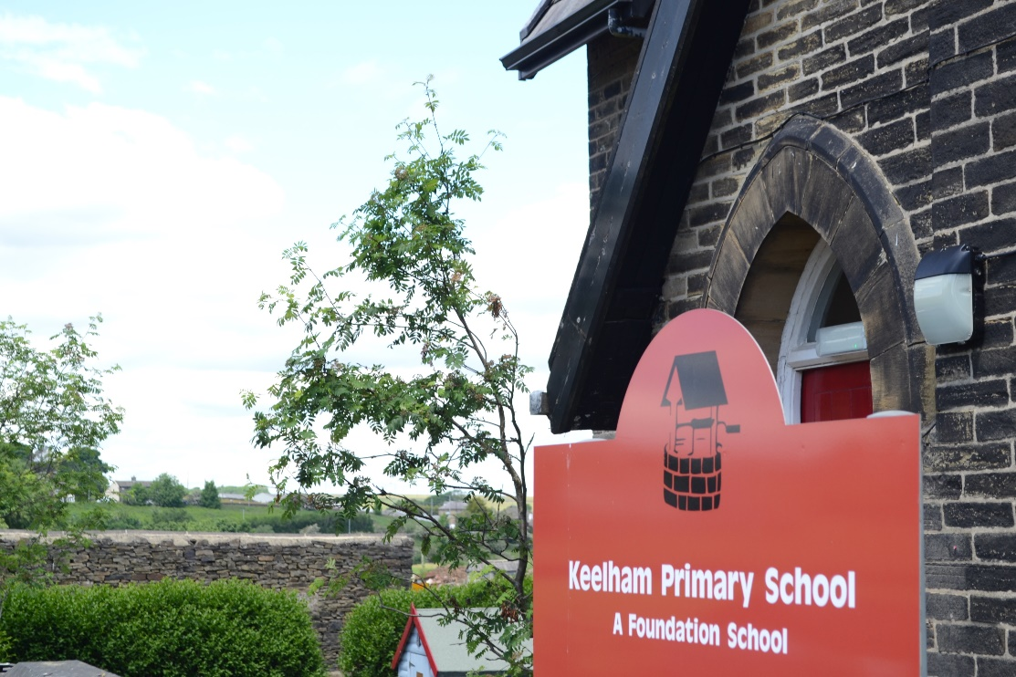
Keelham Primary School

Pupil premium strategy statement

School overview

Metric | Data
School name | Keelham Primary School
Pupils in school | 118
Proportion of disadvantaged pupils | 9.3%
Pupil premium allocation this academic year | £19,795
Academic year or years covered by statement | 2021-22
Publish date | 01 September 2021
Review date | 01 January 2022
Statement authorised by | Robert Hunter
Pupil premium lead | Robert Hunter
Governor lead | Committee C

Disadvantaged pupil progress scores for last academic year

(2019 Published Results)
Measure | Score
Reading | 1.01
Writing | 2.12
Maths | 3.11

Disadvantaged pupil performance overview for last academic year

(2019 Published Results)
Measure | Score
Meeting expected standard at KS2  Reading  Writing  Maths | 83%  100%  83%  100%
Achieving high standard at KS2  Reading  Writing  Maths | 17%  17%  33%  50%

Strategy aims for disadvantaged pupils
Measure | Activity
For all disadvantaged pupils in school to make or exceed nationally expected progress rates in reading. | - Ensure all relevant staff receive training in Phonics.  - Screen all children on entry for SALT and continue this practice throughout school.  - Introduce reciprocal reading strategies in Key Stage 2.  - Appoint a research champion in school, to adopt effective research-proven teaching strategies to improve reading fluency in school.  - Staff at all levels are given a variety of high-quality professional development training to develop pedagogy in the teaching of reading.
To narrow the attainment gap between disadvantaged and non-disadvantaged pupils in writing. | - Introduce a book-based writing curriculum.  - Work with Philip Webb (LAP West Training) to further develop writing journey in school; staff given a variety of high-quality professional development training to develop pedagogy in the writing journey.  - Through regular learning walks, evidence triangulation in frequent writing moderations and review and recovery meetings, SLT ensure that disadvantaged pupils are making good or better progress.  - The teaching of metacognition strategies to encourage children to be self-reflective of their own writing and correct misconceptions and make improvements.
Barriers to learning these priorities address | - Ensuring staff use evidence-based whole-class teaching interventions.  - Ensuring staff have the pedagogy to implement the new reading and writing journey.
Projected spending | Cost  Phonetically decodable books £195  LAP training Costs – Phillip Webb English £520  £715

Teaching priorities for current academic year
Aim | Target | Target date
Progress in Reading | Achieve better than national average progress scores in KS2 Reading (0) | July 22
Progress in Writing | Achieve better than national average progress scores in KS2 Writing (0) | July 22
Progress in Mathematics | Achieve better than national average progress scores in KS2 Writing (0) | July 22
Phonics | Achieve national average expected standard in PSC | July 22
Other | Ensure disadvantaged pupils’ attendance is above 95% | July 22

Remember to focus support on disadvantaged pupils reaching the expected standard in phonics check at end of Y1

Targeted academic support for current academic year
Measure | Activity
Priority 1  Reading | - Phonics screening to take place on entry  - Pupils identified through Review and Recovery meetings  - Identified pupils receive 3x weekly phonics intervention additional to QFT phonics session led by trained SS. (Impact assessed after 6 weeks)  - To upskill support staff with appropriate approaches and pedagogy to teaching interventions.  - All children screened with reading age test on entry  - Pupils identified as needing further fluency practise to read daily with the class teacher.  - A clear reading journey is taught embedded in all year groups.  - High quality text types are purchased to engage and challenge all readers.  - Children respond to their reading daily through the use of a reading comprehension journal.  - Children are regularly exposed to fiction and non-fiction text types which challenge all learners.  - The school environment encourages a love of reading and encourages children to read through ‘Yearn to Learn’ and ‘Love to Read’ texts throughout the term.
Priority 2  Mathematics | - Teachers assess maths effectively to the extent to which key mathematical concepts require revisiting and rebuilding for individuals and groups.  - Observe and share mathematical practice through school and engage in further research and support collaborative conversations.  - To upskill support staff with appropriate approaches and pedagogy to teaching interventions.  - Use White Rose maths premium resources to ensure consistency and continuity of practice and challenge for all learners.  - Identified pupils receive 3x weekly maths intervention additional to QFT mathematics session led by trained SS. (Impact assessed after 6 weeks)
Barriers to learning these priorities address | - Pupils have been working remotely for a considerable time over the past 18 months, some being affected by class bubbles.  - Due to long periods of isolation, pupils’ basic emotional and social needs may not be currently met. This could affect the rate of progress they make academically.
Projected spending | Cost  High quality read texts –Yearn to Learn £384  White Rose Maths Premium resources £120  HLTA intervention costs £5,229  £5,733

Wider strategies for current academic year
Measure | Activity
Priority 1  To providing a breadth of experiences to enhance pupil’s cultural capital. | - To ensure the curriculum is broad, balanced and planned for sequential learning.  - To provide professional teaching in the subjects of Music, Computing and MFL  - The curriculum allows for opportunities to develop cultural development and an understanding of a global world.  - To allow pupils to take part in visits, both virtually and in school, which build on skills and knowledge from curriculum subjects taught in class.  - Subject leaders and class teachers plan enrichment opportunities for all pupils.  - To have themed curriculum days to deepen children’s understanding of specific topic areas
Priority 2  Work with families who require support. | - PIW to liaise with SENCo to identify pupils and families that may require support.  - PIW to work reactively with families who require support.  - PIW to liaise with Thornton Community Centre to provide support for food and social and emotional throughout pandemic.  - PIW to carry out learning conversations sessions with targeted children
Barriers to learning these priorities address | - Poor attendance, including the impact of Covid19  - Ensure targeted children attend school every day.  - Covid19 measures limit visitors coming into school and the curriculum offer they can provide pupils.
Projected spending | Cost  Professionals teaching Music, Computing and MFL £9,690  PIW costs £3,657  £13,347

Monitoring and Implementation
Area | Challenge | Mitigating action
Teaching | Due to staffing resources, SLT need to ensure subject leaders and the wider staff have enough time to receive support from the LAP support and English and Maths teaching hubs in Bradford. | - INSET days allocated during the school year will be used to offer staff high-quality CPD.  - Subject Leaders to be given management time so that they are able to monitor practice, impact and outcomes in their subjects.  - SLT to monitor the impact of interventions through review and recovery meetings.
Targeted support | Ensure that all children in Rec, Year 1,2 and 3 receive recovery time in phonics through targeted intervention by trained SS. | - All targeted children will have small group intervention which will lower the pupil to teacher ratio.  - INSET days planned to train all staff on the delivery of high quality phonics.
Wider strategies | Ensuring that the PIW is able to engage with the hard to reach families.  Ensuring that curriculum enrichment is planned in good time. | - Reintroduction of PIW drop in parent sessions once COVID-19 restrictions allow.  - Work effectively with LAP schools and the community to continue to offer support to vulnerable families.  - SLT to monitor the impact of enrichment planned into the curriculum.  - Class floor books produced to show the impact of these sessions.

Review: last year’s aims and outcomes
Aim | Outcome
Other

