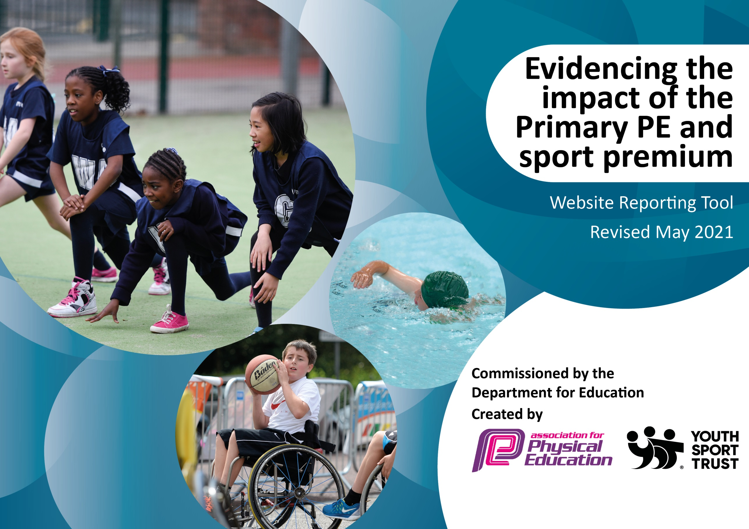

It is important that your grant is used effectively and based on school need. The Education Inspection Framework (Ofsted 2019 p64) makes clear there will be a focus on ‘whether leaders and those responsible for governors all understand their respective roles and perform these in a way that enhances the effectiveness of the school’.

Under the Quality of Education criteria (p41) inspectors consider the extent to which schools can articulate their curriculum (INTENT), construct their curriculum (IMPLEMENTATION) and demonstrate the outcomes which result (IMPACT).

To assist schools with common transferable language this template has been developed to utilise the same three headings which should make your plans easily transferable between working documents.

Schools must use the funding to make additional and sustainable improvements to the quality of Physical Education, School Sport and Physical Activity (PESSPA) they offer. This means that you should use the Primary PE and sport premium to:

- Develop or add to the PESSPA activities that your school already offer
- Build capacity and capability within the school to ensure that improvements made now will benefit pupils joining the school in future years
- The Primary PE and sport premium should not be used to fund capital spend projects; the school’s budget should fund these.
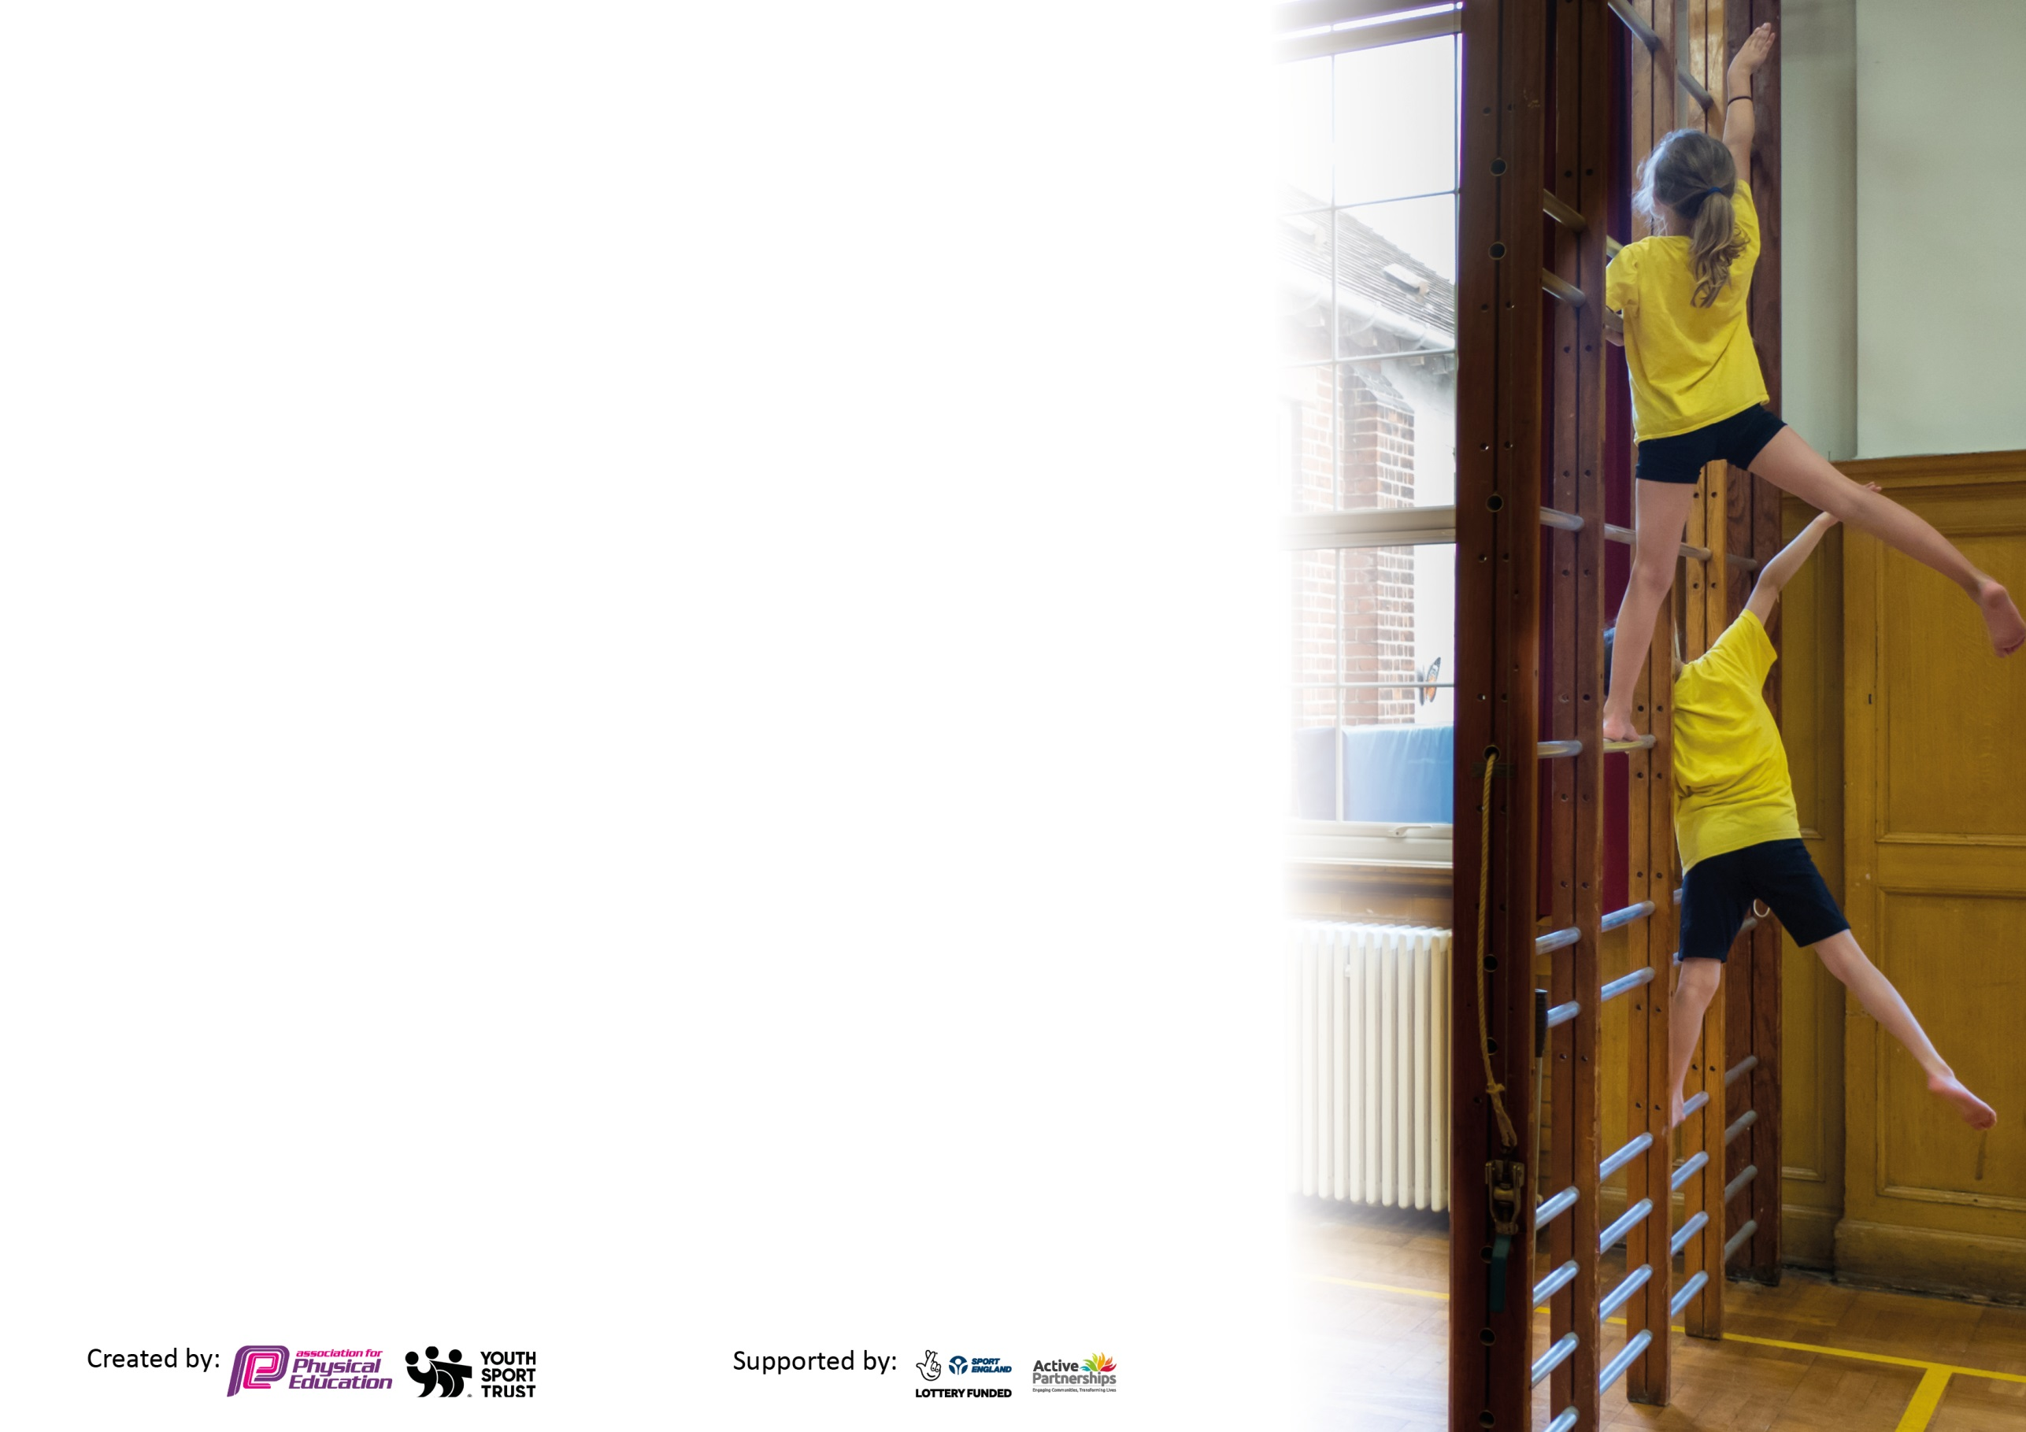
Please visit gov.uk for the revised DfE guidance including the 5 key indicators across which schools should demonstrate an improvement. This document will help you to review your provision and to report your spend. DfE encourages schools to use this template as an effective way of meeting the reporting requirements of the Primary PE and sport premium.

We recommend you start by reflecting on the impact of current provision and reviewing the previous spend.

Schools are required to publish details of how they spend this funding, including any under-spend from 2019/2020, as well as on the impact it has on pupils’ PE and sport participation and attainment by the end of the summer term or by 31st July 2021 at the latest.

We recommend regularly updating the table and publishing it on your website throughout the year. This evidences your ongoing self-evaluation of how you are using the funding to secure maximum, sustainable impact. Final copy must be posted on your website by the end of the academic year and no later than the 31st July 2021. To see an example of how to complete the table please click HERE.

Please note: Although there has been considerable disruption in 2020 it is important that you publish details on your website of how you spend the funding - this is a legal requirement.
Support for review and reflection - considering the 5 key indicators from DfE, what development needs are a priority for your setting and your pupils now and why? Use the space below to reflect on previous spend and key achievements and areas for development.

N.B. In this section you should refer to any adjustments you might have made due to Covid-19 and how these will influence further improvement.
Key achievements to date until July 2020: | Areas for further improvement and baseline evidence of need:
- Pupils continue to have positive role models in Physical Education through their weekly interactions with Youth Sports Development.  - Children working with coaches to complement their teachers input. These coaches have detailed knowledge, understanding, qualifications and experience in a range of sports.  - Children continue to have access to a wide range of sports and have developed skills and competence.  - Attendance to after school clubs (after national restrictions) as there is a sustained offer of extra-curricular activities.  - All pupils have access to extra-curricular sporting activities delivered by high quality coaches during lunchtimes. | - Peer mentoring (coach to teacher) to continue in order to build confidence in teachers and transfer knowledge to them.  - Continue to develop the skills of all pupils across the P.E curriculum.  - Improve performance of pupils in team game sports so that they are fully prepared for competitions.  - Enable pupils to take part in inter school and LA school games and competitions (COVID-19 restrictions allowing).

Did you carry forward an underspend from 2019-20 academic year into the current academic year? YES/NO * Delete as applicable
Total amount carried forward from 2019/2020 £10,275
+ Total amount for this academic year 2020/2021 £16,880
= Total to be spent by 31st July 2021 £27,155

Meeting national curriculum requirements for swimming and water safety.

N.B Complete this section to your best ability. For example you might have practised safe self-rescue techniques on dry land which you can transfer to the pool when school swimming restarts.
Due to exceptional circumstances priority should be given to ensuring that pupils can perform safe self rescue even
if they do not fully meet the first two requirements of the NC programme of study.
What percentage of your current Year 6 cohort swim competently, confidently and proficiently over a distance of at least 25 metres?  N.B. Even though your pupils may swim in another year please report on their attainment on leaving primary school at the end of the summer term 2021.  Please see note above. | 100%
What percentage of your current Year 6 cohort use a range of strokes effectively [for example, front crawl, backstroke and breaststroke]?  Please see note above. | 92%
What percentage of your current Year 6 cohort perform safe self-rescue in different water-based situations? | 85%
Schools can choose to use the Primary PE and sport premium to provide additional provision for swimming but this must be for activity over and above the national curriculum requirements. Have you used it in this way? | Yes/No

Action Plan and Budget Tracking
Capture your intended annual spend against the 5 key indicators. Clarify the success criteria and evidence of impact that you intend to measure to evaluate for pupils today and for the future.

Academic Year: 2020/21 | Total fund allocated: £ | Date Updated:
Key indicator 1: The engagement of all pupils in regular physical activity – Chief Medical Officers guidelines recommend that primary school pupils undertake at least 30 minutes of physical activity a day in school |  |  |  | Percentage of total allocation:
 |  |  |  | %
Intent | Implementation |  | Impact
Your school focus should be clear what you want the pupils to know and be able to do and about  what they need to learn and to  consolidate through practice: | Make sure your actions to achieve are linked to your intentions: | Funding allocated: | Evidence of impact: what do pupils now know and what can they now do? What has changed?: | Sustainability and suggested next steps:
Offer all pupils a daily 30 minutes lunchtime sports club. | - YSD coach employed to work across the dinnertime period.  - Regular meetings between YSD and SLT to measure the impact of engagement of lunchtime provision.  - Year group bubbles timetables to access coach.  - An enhanced curriculum after school that caters for children across school. | £7,004 | - Engagement of pupils accessing lunchtime provision was high (on average 100% of each bubble)  - Pupil voice evidences enjoyment of provision provided.  - An increase has been seen in the participation of disadvantaged due to more accessibility with PE.  - Through daily observations and monitoring by staff, children are engaged and active during lunchtime | - School, in partnership, with YSD to train Year 5 and 6 pupils to become sports leaders who will competently run Friday lunchtime clubs (COVID-19 restrictions dependent).  - Evaluate the after school club sporting offer to pupils, and enrich tgheir experiences with a wide-range of sports.
Key indicator 2: The profile of PESSPA being raised across the school as a tool for whole school improvement |  |  |  | Percentage of total allocation:
 |  |  |  | %
Intent | Implementation |  | Impact
Your school focus should be clear what you want the pupils to know and be able to do and about  what they need to learn and to  consolidate through practice: | Make sure your actions to achieve are linked to your intentions: | Funding allocated: | Evidence of impact: what do pupils now know and what can they now do? What has changed?: | Sustainability and suggested next steps:
Engage identified pupils to attend provision of extra-curricular activity. | - Through discussion with PE lead, YSD and SLT, a range of sporting activities agreed to be run during active lunchtimes.  - Vulnerable children identified and encouraged to take part in the extra sessions.  - Pupil voice taken to measure their engagement.  - Children who attend Crew at the morning and afternoon sessions take part in active learning on the Muga and playground. | £4,130 | - Pupil voice evidences enjoyment of provision provided.  - Participation in afterschool clubs March 21 onwards:  Year 1, 2 46%  Year 3, 4 48%  Year 5, 6 41% | - Continue to reach out to vulnerable pupils during the academic year 21/22.  - Evaluate and implement a range of sporting activities for pupils attending before and after school crew provision.

Key indicator 3: Increased confidence, knowledge and skills of all staff in teaching PE and sport |  |  |  | Percentage of total allocation:
 |  |  |  | %
Intent | Implementation |  | Impact
Your school focus should be clear | Make sure your actions to | Funding | Evidence of impact: what do | Sustainability and suggested
what you want the pupils to know | achieve are linked to your | allocated: | pupils now know and what | next steps:
and be able to do and about | intentions: |  | can they now do? What has
what they need to learn and to |  |  | changed?:
consolidate through practice:
Staff to work with specialist coaches, developing their confidence and practice when teaching the P.E national curriculum. | - Staff will work alongside the coaches that come into school. High quality CPD for staff members.  - Support with planning units of learning and individual lesson plans. | £4,130 | - Due to the national restrictions implemented in January, coaches supported staff on their remote offer.  - Zoom remote PE lessons engaged all learning from home as well as learners in school.  - Staff planned effective P.E lessons taking into consideration the excellent high quality resources available online to complement delivery. | - This objective is to continue through 21/22 academic year as it was negatively impacted by the COVID-19 national restrictions and continued bubble closures.  - Use of interactive assessment tool.
Key indicator 4: Broader experience of a range of sports and activities offered to all pupils |  |  |  | Percentage of total allocation:
 |  |  |  | %
Intent | Implementation |  | Impact
Your school focus should be clear | Make sure your actions to | Funding | Evidence of impact: what do | Sustainability and suggested
what you want the pupils to know | achieve are linked to your | allocated: | pupils now know and what | next steps:
and be able to do and about | intentions: |  | can they now do? What has
what they need to learn and to |  |  | changed?:
consolidate through practice:
All pupils will experience a range of sporting activities and develop skills and competence in them. | • Children to participate in competitive sports at Beckfoot Thornton throughout the school year.  • SLT and PE to monitor and review of after-school sports clubs and lunchtime provision.  • Research whole school sport initiatives throughout the year and champion initiatives that reflect the goals at Keelham.  • Provide opportunities for all children to take part in whether this is in school time or during before and after school provision. | Redevelopment of Muga  £11,891 | - Children have received a range of sports during in school time monitored half termly by SLT. | - School council to evaluate the sports and offer suggestions of new sports not experienced before to replace current after school clubs and lunchtime provision.

Key indicator 5: Increased participation in competitive sport |  |  |  | Percentage of total allocation:
 |  |  |  | %
Intent | Implementation |  | Impact
Your school focus should be clear | Make sure your actions to | Funding | Evidence of impact: what do | Sustainability and suggested
what you want the pupils to know | achieve are linked to your | allocated: | pupils now know and what | next steps:
and be able to do and about | intentions: |  | can they now do? What has
what they need to learn and to |  |  | changed?:
consolidate through practice:
For all children to have the opportunity to take part in competitive sporting events within the local community. | - Continue to engage with the local authority school sin competitions at Beckfoot Thornton  These sports include:  - Sports hall Athletics  - Cricket  - Football  - Hockey  - Bocca  - Badminton  - Table Tennis  - Cross Country  - YSD to support school with the coaching at competitive team sports and attend all competitive events. |  | No competitive team sports carried out due to COVID-19 restrictions. | Objective to be carried over into the next academic year where we hope that there is possibility for competitive team sports to restart.

Signed off by
Head Teacher: | Robert Hunter
Date: | 8.7.21
Subject Leader: | Pam Croft
Date: | 8.7.21
Governor: | Carol North
Date: | 8.7.21

