Rapid Testing for Staff |  |  | Risk Rating including mitigations (Likelihood x Severity = Risk)
 |  |  | Likelihood | Severity |  | Risk
 |  |  | 5 | 1 |  | 5
Who might be at risk? | Risk Focus | How are you already controlling this risk? | Further mitigations / protective measure required? |  | Who needs to carry out the action? |  | When is the action needed by?
Staff | COVID-19 spreading in the school community | - Schools following government recommended control measures set out in the school’s protective measures risk assessment.  - Mass testing of staff will take place twice a week (Sunday evening and Wednesday evening) and staff will take these tests at home. These tests are to be taken 3-4 days apart.  - Tests to be taken before staff come into work.  - Staff results to be recorded on a staff register and recorded by the person online. This will support identifying staff with positive results for contact tracing and managing stock and distribution.  - Those with symptoms are also expected to order a test online or visit a test site to take a polymerase chain reaction (PCR) test to check if they have the virus.  Government Guidance 27.9.21:  Asymptomatic testing  Testing remains important in reducing the risk of transmission of infection within schools. That is why, whilst some measures are relaxed, others will remain, and if necessary, in response to the latest epidemiological data, we all need to be prepared to step measures up or down in future depending on local circumstances.  Staff and secondary school pupils should continue to test twice weekly at home, with lateral flow device (LFD) test kits, 3 to 4 days apart. Testing remains voluntary but is strongly encouraged.
 | Regular communication to staff | - Staff meeting carried out on 20.1.21  - Email including letter from School and Information booklet given to staff on 21.1.21 including:  - what rapid testing is, about using the how to guide and the video content available  - the requirement for them to report their test results.  - the process and who to contact if they have an incident while testing at home.  - Video explaining how to carry out the LFT.  - Covid Co-ordinator: Robert Hunter, (Head teacher) Katie Watson (Business Manager)  Covid Registration Assistant: Sharon Gilbert (Admin Assistant)  - Staff will need to sign for their test kits and the lot number will be recorded against their name. Staff will collect their first set of tests and instructions from the school office.  - Staff give consent to testing through Microsoft form – sent to all staff on 25.1.21
 | Tests to be stored correctly and collection managed in a safe way | - Tests to be kept securely in Headteacher’s office to prevent unauthorized access.  - Not be stored outside. Stored in a cool, dry place. Test kits will be stored in a temperature between 2 and 30 degrees.  - The kits should be used at room temperature (15 to 30 degrees). If the kit has been stored in a cool area less than 15 degrees, leave it at normal room temperature for 30 minutes before using.  - Enough space for social distancing will be allowed when giving out tests.  - Tests will be labelled with names and linked lot number and a form to sign will be made available as part of self-service. This negates the need for the station to be staffed. Those collecting their kit should:  - wear appropriate face covering at all times  - hand sanitise before collecting and signing  - maintain 2m from staff coming to collect their test
 | Staff not reporting results | - Void, double void and positive results are communicated to the Head teacher once the test is completed.  - All test results must be communicated by Microsoft Form to school office as soon as the test is complete.  - Staff must report their result online as per the instructions as soon as the test is completed either online or by telephone as per the instructions in the home test kit to NHS Track and Trace.
 | Low uptake on taking tests. | - Tests are optional and are not mandatory. Staff to opt in after they have read key information and privacy notice to understand data protection for testing.  - Staff to notify school of their intentions to/or not to test via secure Microsoft Form sent out 25.1.21  - Staff are able to ask key questions about the testing to Head teacher via Microsoft Form.  - For those not completing, this will stay anonymous but must notify Head teacher.
 | Swabs are taken incorrectly causing a false reading or cause contamination | - Schools following government control measures.  - Covid Coordinator has undertaken relevant training and informed staff of how to access the portal/training videos/documents prior to taking part in the community testing scheme.  - Instructions dated 15th January 2021 to be issued alongside the kits and staff informed that the old instructions which are contained in box must be recycled  - Test conducted on a dry, clean, flat surface.  - Hands washed or use sanitiser before taking the test.  - Online information, training and webinars available. Video available on how to take your own test.  - Information with the kits to be followed.  - Regular communication with staff about the testing process.  - If test is void, take another test. If 2 void results in a row, a PCR test should be taken.  - If a number of tests give a void result, unclear results or leaking/damaged tubes should be recorded and escalated to the DfE helpline.  - Covid Coordinator to be responsible for incident reporting on a school wide issue:  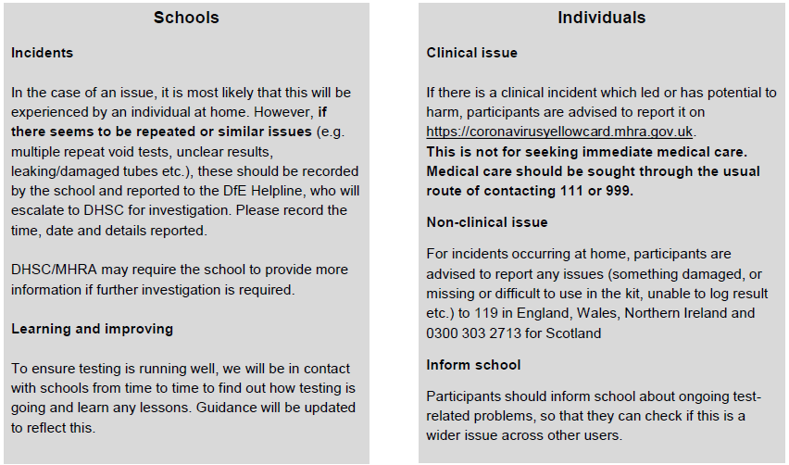
 | Positive test is identified | - Staff member will contact Head teacher after receiving the positive Test result  - Staff member to book a PCR test straight away by contacting 119 or NHS Coronavirus website  - Head teacher, Covid coordinator and Covid administration assistant to contact PHE, Bradford Council and NHS Track and trace  - Chair of Governors, John Ashworth, made aware of the situation  - Staff member to work remotely (if well enough).  Government Guidance 27.9.21  Confirmatory PCR tests:  - Staff and pupils with a positive LFD test result should self-isolate in line with the stay at home guidance for households with possible or confirmed coronavirus (COVID-19) infection.  - They will also need to get a free PCR test to check if they have COVID-19.  Whilst awaiting the PCR result, the individual should continue to self-isolate.  - If the PCR test is taken within 2 days of the positive lateral flow test, and is negative, it overrides the self-test LFD test and the pupil can return to school, as long as the individual doesn’t have COVID-19 symptoms.

