Behaviour Policy 2019

Keelham Primary School

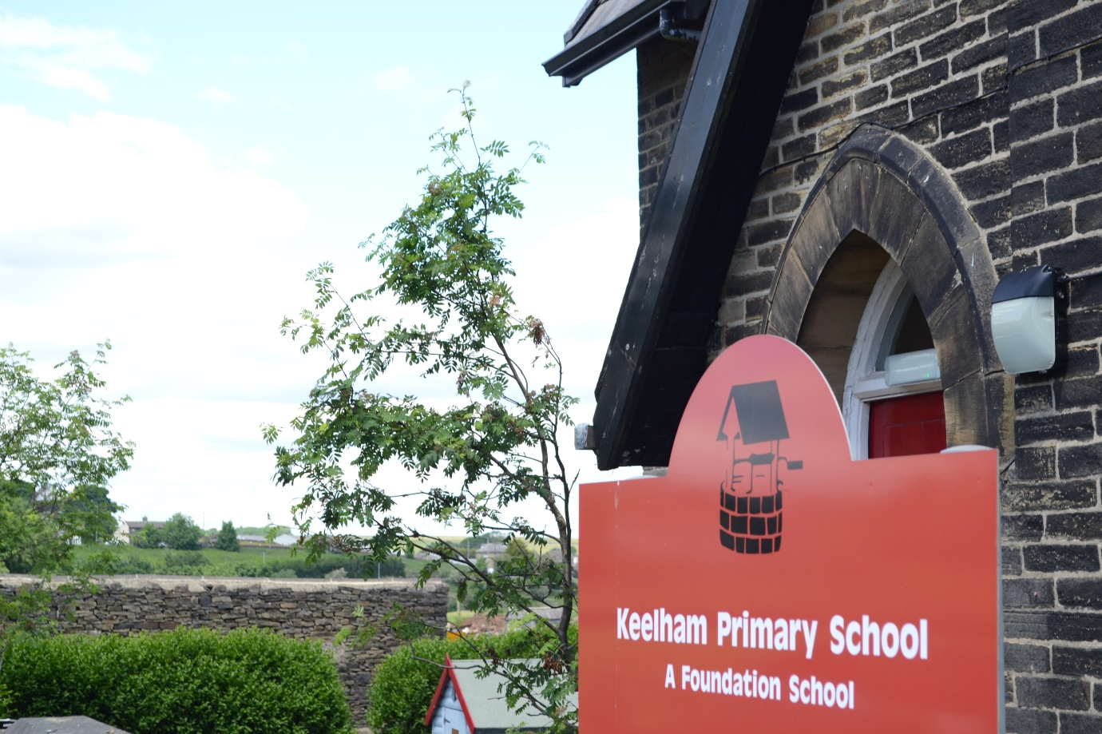

Approved by: |  | Date:
Last reviewed on:
Next review due by:

Policy Statement
Keelham Primary School is committed to creating an environment where exemplary behaviour is at the heart of productive learning. Everyone is expected to maintain the highest standards of personal conduct, to accept responsibility for their behaviour and encourage others to do the same. Our behaviour policy guides staff to teach self-discipline not blind compliance. It echoes our core values with a heavy emphasis on respectful behaviour, a partnership approach to managing poor conduct and timely interventions that support staff and learners.
Aim of the policy
To create a culture of exceptionally good behaviour: for learning, for community for life
To ensure that all learners are treated fairly, shown respect and to promote good relationships
To limit acknowledgement and attention to those learners showing poor conduct.
To help learners take control over their behaviour and be responsible for the consequences of it.
To build a community which values kindness, care, good humour, good temper, good behaviour and empathy for others.
To promote community cohesion through improved relationships.
To ensure that excellent behaviour is a minimum expectation for all.
Purpose of the policy
To provide simple, practical procedures for staff and learners that:
- Recognise behavioural norms
- Positively reinforces behavioural norms
- Promote self-esteem and self-discipline
- Teach appropriate behaviour through positive interventions

At Keelham we aim to:
- Provide a safe, comfortable and caring environment where optimum learning takes place
- Provide clear guidance for children, staff and parents of expected levels of behaviour
- Use a consistent and calm approach
- Ensure all adults take responsibility for managing behaviour and follow-up incidents personally
- Ensure all adults use consistent language to promote positive behaviour and
- Use restorative approaches instead of punishments
- Praise children publicly and remind children in private.

All staff must:
- Take time to welcome children at the start of the day
- Be in their rooms at the start of each session to meet and greet
- Always pick up on children who are failing to meet expectations
- Give first attention to those children who are doing the right thing
- Encourage sensible walking and a sense of pride in our school
- Always redirect children by referring to the school’s aims and rules
- Be in control of their emotions when speaking to children

The Head teacher and The Senior Leadership Team must:
- Be a visible presence around the school
- Regularly celebrate staff and children whose efforts go above and beyond expectations
- Encourage use of positive praise, phone calls/texts/notes home and certificates/stickers
- Ensure staff training needs are identified and met
- Monitor CPOMS to target and assess interventions
- Support teachers in managing children with more complex or challenging behaviours

Members of staff who manage behaviour well:
- Deliberately and persistently catch children doing the right thing and praise them in front of others
- Know their classes well and develop positive relationships with all children
- Relentlessly work to build mutual respect
- Remain calm and keep their emotion for when it is most appreciated by children
- Demonstrate unconditional care and compassion
- Deal with primary behaviour
- Always follow up behaviour incidents
- Communicate with parents/carers regularly about positive and negative behaviour

Children want teachers to:
- Give them a ‘fresh start’
- Help them learn and feel confident
- Talk to children and investigate incidents fully
- Remain calm
- Be just and fair
- Have a sense of humour

The school has 3 simple rules which can be applied to a variety of situations and are taught and modelled explicitly. The rules are:

Be Ready. Respectful. Safe.
Our Rules |  | Visible Consistencies | Over and Above Recognition
- Be ready  - Be respectful  - Be safe | 1. 2.  3.  4.  5.  6. | Daily meet and greet  Persistently catching children doing the right thing  Picking up on children who are failing  to meet expectations  Accompanying children to the playground/exit door at the end of every day  Praising in public (PIP), Reminding in private (RIP)  Consistent language | - Recognition boards  - Stickers  - Phone call/text home  - Verbal praise  - Notes home  - Dojos and clever sticks/ table praise  - SLT praise  - Show work to another adults  - HT award

Celebration Assembly
Each week there will be a celebration of achievement assembly where class certificates for being Kind, persevering and succeeding are presented. This is for outstanding achievement (this could be for academic achievement, good citizenship or extra effort) that week.

Other rewards
Children will be praised for their effort or behaviour through recognition boards in all classes and in the hall. These recognition boards can transfer to the class Dojo system of reward which are shared with parents directly. In Foundation Stage there is the use of Clever Sticks.

Stepped Consequences - Gentle Approach, use child’s name, child level, eye contact, deliver message
1. REMINDER | A reminder of the three school rules delivered privately wherever possible.  I noticed you chose to …… (noticed behaviour)  This is a REMINDER that we need to follow the school rule…. (repeat which school rule they have broken)  You now have the chance to make a better choice  Thank you for listening  Example - ‘I notice that you’re running. You are breaking school rule number 3. Remember that in school we walk sensibly. Please show me your sensible walking. Thank you for listening.’
2. CAUTION | A clear verbal caution delivered privately, wherever possible, making the child aware of their behaviour and clearly outlining the consequences if they continue.  I noticed you chose to …… (noticed behaviour)  This is the second time I have spoken to you  If you chose to break the rule again there will be a consequence  Think carefully about your next step  Example – ‘I notice that you are not getting on with your work. You are not ready to learn. This is now the second time I have spoken to you about this. You are choosing to break rule number 2. If this behaviour continues then there will be a consequence. Think carefully about your next step.’
3. LAST CHANCE | Speak to the student privately and give them a final opportunity to engage. Offer a positive choice and refer to previous examples of good behaviour. Use the 30 second scripted intervention. If a child reaches this step, then 2 minutes is owed

after class. This is not part of some future negation on behaviour. It cannot be removed, reduced or substituted.
I noticed you chose to …… (noticed behaviour) This is the third time I have spoken to you.
You need to speak to me for two minutes after the lesson.
If you choose to break the rules again you will leave me no choice but to ask you to, (work at another table/work in another classroom / go to the quiet area etc ………….) (learner's name),
Do you remember when ………………………………………. (model of previous good
behaviour)? That is the behaviour I expect from you. Think carefully. I know that you
can make good choices Thank you for listening / I’m glad we had this conversation Example - ‘I have noticed you are not ready to do your work. You are breaking school rule number 1. You have now chosen to catch up with me at playtime for 2 minutes. Do you remember that yesterday you started your work straight away and got it finished? That is what I need to see today. Remember you can make the right choice and show me you are ready to work. Thank you for listening.’
4. | TIME OUT | Time out might be a short time outside the room, on the thinking spot or on the bench outside at playtime. It is a few minutes for the child to calm down, breathe, look at the situation from a different perspective and compose themselves. Timeout needs to be recorded on CPOMS.  I noticed you chose to …… (noticed behaviour)  You need to………….(Go to quiet area / Go to sit with other class / Go to another table etc)  Playground: You need to ………….(Stand by other staff member/ me / Sit on the picnic bench/ stand by the wall etc)  I will speak to you in two minutes  Example - ‘I have noticed you chose to use rude words. You are breaking the school rule of showing respect. You have now chosen to go and sit in the quiet  area. I will come and speak to you in two minutes. Thank you for listening.’  If a child is receiving time out it should be no longer than 5 minutes in the class or in another class. If the child goes to another class, their behaviour is not to be discussed by any other adults.  *DO NOT describe a child’s behaviour to other adults in front of the child*
5. | FOLLOW UP – REPAIR &  RESTORE | This might be a quick chat at breaktime/lunchtime or a more formal meeting such as a restorative conversation. In the playground this might be a private chat in the playground or the child might be brought inside for a more formal meeting. Not every incident needs to be resolved with a restorative conversation but all behaviours need to be followed up with a conversation with that adult. A restorative conversation needs to used when trust is broken or when the behaviour has gone under and below the minimum standards. When tempers are frayed, when manners have disappeared or when things have been said that should not have been said.  It is important that the restorative conversation only takes place when everyone is calm. Please remember that recovery time after a period of crisis is, on average, 40 minutes.  - What happened? (Neutral, dispassionate language.)  - What were you feeling at the time?  - What have you felt since?  - How did this make people feel?  - Who has been affected? What should we do to put things right? How can we do things differently?
 |  | As we will not address secondary behaviour during the stepped consequences, it may be appropriate to make a note of them and follow up in the restorative conversation.
*Remember it’s not the severity of the sanction, it’s the certainty that this follow up will take place that is important.

30 Second Scripted Intervention
The 30 second interventions demands careful and often scripted language. It is carefully planned, utterly predictable and safe way to send a clear message to the child: ‘You own your behaviour. Your poor behaviour does not deserve my time. You are better than the behaviour you are showing today (and I can prove it!).’ It should leave the child thinking about their actions and knowing that someone important believes they are better. At the pivotal point of behaviour management, you can address difficult behaviours while leaving your relationship with the child perfectly intact.
There is no one ‘correct’ script and you may have to adapt it for your context. However, this can be the basis for your intervention.

I noticed you are … (having trouble getting started/shouting out on the carpet/throwing pencils) It was about …. (not being ready/ or respectful of people/ not keeping other and yourself safe) that you broke
You have chosen to …. (give me two minutes at the end of the lesson/move to another table/catch up with your work at breaktime)
Do you remember last week when… (arrived on time every day/got on the recognition board/completed all your work)
That is who I need to see today…
Thank you for listening (Then give the child some processing time)

Sanctions should
- Make it clear that unacceptable behaviour affects others and is taken seriously
- Not apply to a whole group for the activities of individuals.
- Be consistently applied by all staff to help to ensure that children and staff feel supported and secure

Sanctions need to be in proportion to the action
It should also be made very clear that it is the behaviour that is unacceptable, and any sanction should address this, not be made personal to the child.

Adult Strategies to Develop Excellent Behaviour
IDENITIFY the behaviour we expect
Explicitly TEACH behaviour
MODEL the behaviour we expect
PRACTISE behaviour
NOTICE excellent behaviour
CREATE conditions for excellent behaviour

CPOMS

Behaviour incidents may be logged as a way of recording ongoing behaviour issues or more extreme behaviour. This may be used as an observational tool that allows staff to record behavioural concerns. Categories on CPOMS for behaviour logs are: Time Out, Playground Behaviour, Off Site Behaviour, Parental Contact Behaviour, Internal exclusion and Exclusion.
If a child receives a time out, then this needs to be recorded on CPOMs and SLT will be tagged in to the report.
If a parent has been contacted with regards to a behaviour issue, then this needs to be logged on CPOMS and again SLT will be tagged.
If a member of SLT has been part of the follow up conversation, then this needs to be logged on CPOMS.

All racist and homophobic incidents will be dealt with by the adult who has witnessed them but they will be reported to the Headteacher. These will be reported on CPOMS as racism or homophobic by the adult who witnessed it and investigated it.

All allegations of bullying will be investigated thoroughly by the teacher involved. The outcome of this investigation will always be shared with SLT and reported to parents if appropriate. If a proven bullying incident (including cyber bullying, homophobic bullying and bullying related to disability) has occurred then this will be reported on CPOMs as bullying.

The Safeguarding Team will regularly monitor behaviour logged on CPOMS and will report back to the Governors.

BEHAVIOUR PATHWAY

Reminder
Caution
Last Chance
Time Out

Follow up/Reparative Conversation (It may be appropriate to ask a Support assistant or the PIW to prepare the child for the follow up/reparative conversation)
Should you feel, using your professional judgement, a senior member of staff needs to be part of the Follow-up /Reparative Conversation then follow the guidelines below:
Speak to HT/SLT without the child present
Speak to the child with HT/SLT present
Parents phoned
Parents called to school
Internal exclusion
Exclusion

Exclusion
Internal exclusion can be used to exclude pupils from the playground at break or lunchtime or if a pupil needs a longer ‘time out’ from the lesson to reflect on their behaviour. It is the decision of the SLT whether a pupil needs to be isolated, when, where and for how long. Pupils need to be sent with their work to complete and their parents are to be informed as soon as possible and no later than the end of the school day by a member of the SLT.
Longer term internal exclusion will be used in discussion with parents where a child may be at risk of fixed-term exclusion and requires time to reflect on their behaviours. The SLT will ensure where and when this will take place and ensure the provision for the pupil during the day.
In cases of extremely serious misbehaviour exclusion will be considered. A decision to exclude a pupil will be taken only:
- In response to serious breaches of the school's Behaviour Policy
- The child needs time to reflect on their behaviour
- To give the school time to create a plan which will support the child better
- The child being at home will have a positive impact on future behaviour
- If allowing the pupil to remain in school would seriously harm the education or welfare of the pupil or others in the school.
All exclusions will be at the discretion of the Head Teacher. In the event of the Headteacher making the decision to exclude a pupil for either a fixed term, lunchtime or permanent exclusion, Keelham Primary School will follow the procedure outlined in the document below.

“Exclusion from schools and pupil referral units in England”
A guide for those with legal responsibilities in relation to exclusion – Department for Education 2011

Beyond the School Gate
Whilst this behaviour policy refers mainly to the behaviours of pupils within school premises, the school reserve the right to discipline beyond the school gate.
Our policy covers any inappropriate behaviour when children are:
- taking part in any school organised or school related activity
- travelling to or from school
- wearing school uniform
- in some way identifiable as a pupil from our school
- poses a threat to another pupil or member of the public
- could adversely affect the reputation of the school
In the incidences above, the head teacher may notify the police of any actions taken against a pupil. If the behaviour is criminal or causes threat to a member of the public, the police will always be informed.

Safeguarding Allegations

Occasionally, allegations may be made against children by others in school, which are of a safeguarding nature. These need to be referred immediately to the Designated Safeguarding Lead (The Headteacher or Deputy Head teacher) who will follow procedures from the Child Protection and Safeguarding Policy (September 2021).

Pupil support systems
For pupils who are having persistent behaviour difficulties the school will provide targeted pastoral support or mentoring by adults or peers. Our school learning mentor will work closely with targeted pupils and their families. Individual Education plan/behaviour plans will set small and achievable targets and possible resources and strategies will be identified. All pupils regardless of gender, race, age, ability or disability have the right to feel safe and secure at school. We will encourage equal access to praise, incentives and rewards. Staff will be alert to signs of bullying or racial harassment and will follow school procedures for dealing with such incidents (anti bullying policy).

Out of School Behaviour
The school is committed to ensuring our pupils act as positive ambassadors for us. Taking the above into account, we expect the following:
- Good behaviour to and from school, on educational visits or during learning opportunities in other schools
- Positive behaviour which does not threaten the health, safety or welfare of our pupils, staff, volunteers or members of the public.
- Reassurance to members of the public about school care and control over pupils in order to protect the reputation of the school.
- Protection for individual staff and pupils from harmful conduct by pupils of the school when not on the school site.
- The same behaviour expectations for pupils on the school premises apply to off-site behaviour.

Sanctions and Disciplinary Action – Off-Site Behaviour
Sanctions may be given for poor behaviour off the school premises which undermines any of the above expectations and regardless of whether or not it is an activity supervised directly by school staff. Sanctions may be in the form of withdrawal of privileges, fixed term exclusion or in very serious cases, permanent exclusion. In issuing sanctions, the following will be taken into account:
- The severity of the misbehaviour
- The extent to which the reputation of the school has been affected
- Whether pupils were directly identifiable as being a member of our school
- The extent to which the behaviour in question could have repercussions for the orderly running of the school and/or might pose a threat to another pupil or member of staff (e.g. bullying another pupil or insulting a member of staff).
- Whether the misbehaviour was whilst the pupil was taking part in learning opportunities in another school, participating in a sports event (and in any situation where the pupil is acting as an ambassador for the school) which might affect the chances or opportunities being offered to other pupils in the future.

Application
This behaviour policy is for all of our school community. If it is to be effective, everyone must use it with confidence and consistency.

Monitoring and review This policy is monitored by the Headteacher, who reports to governors about the effectiveness of the policy.
It will be reviewed annually and appropriate to new legislation or to the needs of the school.
Please read in conjunction with the following Policies-
- Safeguarding Policy
- Anti-bullying Policy

