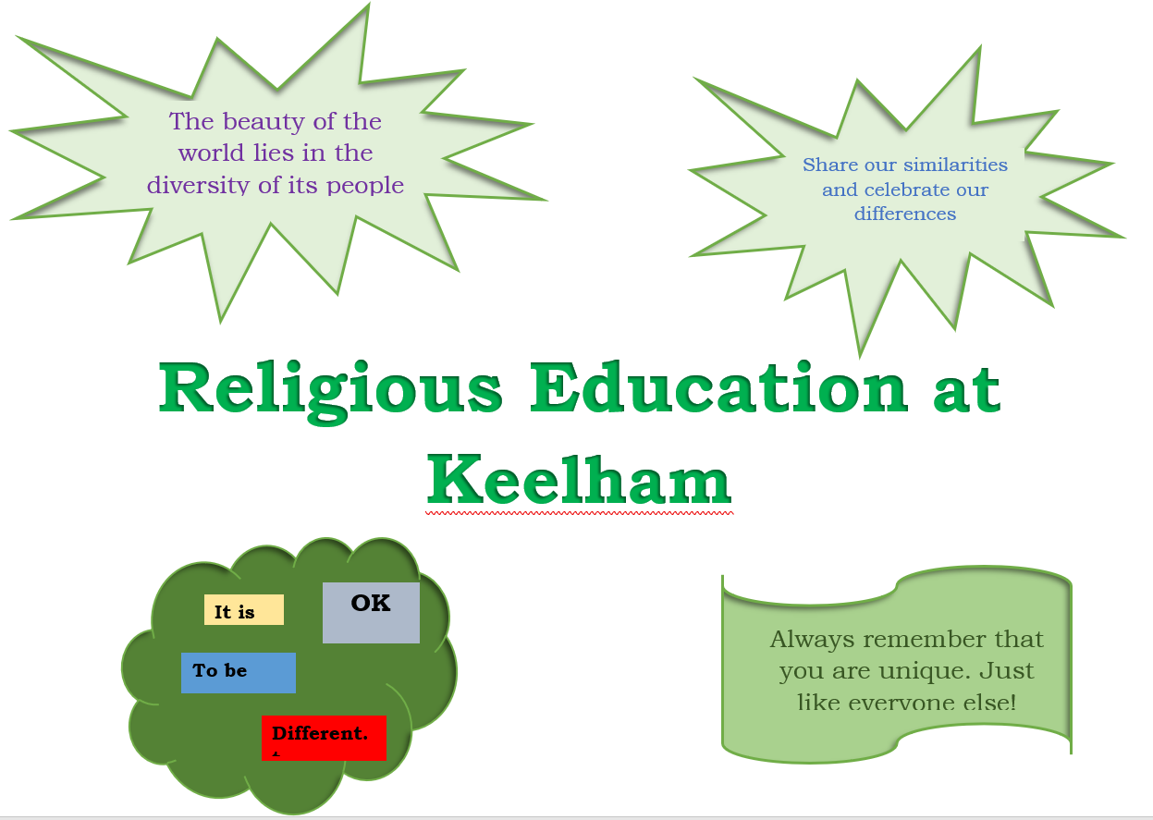
Intent
Religious education has equal standing in relation to core subjects of the National Curriculum in that it is compulsory for all pupils. It is neither a core nor foundation subject.
Through our Religious Education curriculum we aim to engage pupils in enquiring into and exploring questions from the study of religion and belief so as to promote their personal, spiritual, moral, social and cultural development. We aim to provide learners with knowledge and understanding of Christianity and other principal religious traditions and beliefs as well as non-religious beliefs and traditions. We aim to develop learner’s understanding of the ways in which beliefs influence people in their behaviour, practices and outlook and develop a positive attitude towards other people who hold beliefs that are different from their own. The children will be given opportunities to develop critical thinking skills.
Implementation
We follow the agreed syllabus for Bradford which is called “Believing and Belonging 2019-24.”
Children in all key stages will investigate the beliefs and practices of religions and other world views
Foundation Stage
Key Stage 1 | Christianity | Islam | Non-religious world view
Key Stage 2 | Christianity | Islam | Non-religious world view | Judaism | Sikhism

List of units of work 2019-24 West Yorkshire Hub RE Believing and Belonging
EYFS
- Where do we live and who lives there?
- How do Christians celebrate Christmas?
- What makes a good helper?
- What can we see in our wonderful world?
- Who and what are special to us?

Year 1
- Which books and stories are special?
- How do we celebrate special events?
- What does it mean to belong to a church or mosque?
- How and why do we care for others?
- Who brought messages about God and what did they say?

Year 2
- How is new life welcomed?
- How can we make good choices?
- How and why do people pray?
- How can we look after the planet?
- What did Jesus teach and how did he live?
Year 3
- How do Jews remember God’s covenant with Abraham and Moses?
- What is Spirituality and how do people experience this?
- What do Christians believe about a good life?
- What do the creation stories tell us?
Additional unit: Who can inspire us?
Year 4
- How are important events remembered?
- What faiths are shared in our country?
- How do the Five Pillars guide Muslims?
- Why are Gurus at the heart of Sikh belief and practice?
Year 5
- Why are some journeys and places special?
- What values are shown in codes for living?
- Should we forgive others?
- What do Christians believe about the old and new covenants?

Year 6
- How do Sikhs show commitment?
- What do Christians believe about Jesus’ death and resurrection?
- How does growing up bring responsibilities?
- How do Jews remember the Kings and Prophets in worship and life?
Elements of all faiths can be included in all years (e.g. festivals) and as a response to local needs and circumstances. RE should recognise and reflect variety within different religions and other systems of belief beyond the six defined world faiths.
The curriculum should develop both systematic knowledge and thematic enquiry. Diversity between and within traditions must be recognised and RE will explore lived experience as well as texts and doctrines RE lessons are timetabled so that pupils are provided with 1 hour of RE each week. Lessons will be taught by the class teacher/ a qualified teacher covering PPA/an HLTA. The school has a subject leader who supports and monitors the subject.
Each unit of work will focus around a key question related to the subject content of the syllabus. Enquiry and investigation of the key question should include at least three elements:
1. An analysis of the question;
2. A critical investigation of relevant beliefs, practices and ways of life;
3. A reasoned and critical response.
Impact
Religious Education extends the knowledge and understanding of religions and beliefs and develop a religious vocabulary and enables pupils to interpret religious symbolism in a variety of forms. The can reflect on questions of meaning, offering their own thoughtful and informed insights into religious and secular world-views • explore ultimate questions of beliefs and values in relation to a range of contemporary issues in an ever-changing society The impact our RE curriculum is also sought directly from the pupils as surveys and questionnaires are used to gather pupils’ voice on this subject and together with summative assessment, action can be taken to further develop the RE of children.
Achievement and Progress
We assess progress of pupils against the end of key stage statements in the syllabus. The units of work specify age-related expectations within the key stages.
Reporting
At Keelham we will report on progress in RE in line with the core principles of assessment outlined by the DfE. We will report to parents on individual pupils’ achievement relative to the end of key stage statements in at least years 2 and 6 or when a pupil leaves school.
Withdrawal from RE
Parents have a statutory right to withdraw a child from religious education. If a parent is considering withdrawal from RE, school will listen to their concerns, inviting them to do so with the head teacher or other representative of the school. We work hard to ensure that any reservations or doubts may be accommodated to avoid withdrawal but recognise that a parent has this right if reservations cannot be resolved. Any formal decision to withdraw should be made in writing to the head teacher. We will ask parents if they wish to continue the withdrawal each year.
If a pupil is withdrawn, the school has a duty of care to look after the pupil, but not to provide alternative education. Any arrangements made must not incur extra cost for the school or the local authority.
Enquiries and questions
The school welcomes enquiries or questions about RE. In the first instance parents should contact their child’s class teacher through the school office.

