Reception Admissions Policy
2022/23

Keelham Primary School

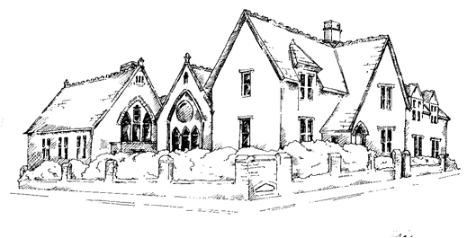

Approved by: |  | Date:
Last reviewed on: | July 2021
Next review due by: | July 2022

KEELHAM PRIMARY SCHOOL
RECEPTION ADMISSIONS POLICY-2022-23

Admission of Pupils

Keelham Primary School will admit 15 pupils each year into the reception class.

Previous admission to our Nursery class does not guarantee a place in our Reception class and all children must apply for a place within school.

Pupils will be offered a full-time place in the September of the academic year in which their fifth birthday falls.

If the school or parents feel that a full-time place is not appropriate before the child reaches statutory school age, a deferred place or part time place can be offered.

Oversubscription

Where applicants for admission exceed the number of places available the following criteria will be applied in the order set out below to decide which children to admit:

- Children looked after by the Local Authority and looked after children who have ceased to be so because they were adopted (or become subject to a residence order or special guardianship order).

- Siblings* of children already in school, living at the same home address and who will be attending school at the time of admission.

- Children who live closest to school. The distance will be measured by the shortest distance by accessible road from directly outside the home address* to directly outside the main school gates. Where the offer of places to applicants measuring equal distance would lead to over subscription, the decision who will be offered a place would be made by random selection.

*2 – The term ‘sibling’ means a brother or sister who lives with the same family at the same address. Children living permanently with the same family, e.g. fostered, adopted and step children are also included. Twins or triplets – where a family of twins or triplets request admission and only one of the siblings can be offered a place, the remaining siblings will also be offered places above the admission number.

*3 – “Home address” refers to the child’s permanent home at the date of admission. Where the child lives with parents with shared responsibility, it is for the parents to determine which address to use when applying for a primary school. Once a place has been allocated the school will need secure evidence of the child’s residency. This will take form of child benefit information of family tax credit details. If this cannot be secured the place may be withdrawn.

The above criteria shall be over-ridden and a place offered:-

A child, who has an Education Health and Care Plan which names Keelham Primary School, will be admitted without reference to the above criteria, if school can meet the child’s needs.

Pupils will not be admitted above the published admission number for the school unless:

- Twins and children from multiple births when one of the siblings is the last child to be admitted.
- The pupil is admitted as part of the fair access protocol, agreed with all schools in the area.

Applicants who are not allocated places at the school during the normal admission to reception should request through Local authority to be placed on the school waiting list. The list will be kept for one year. Late applications will be added to the list and treated in the same way as other refused applications.

