 | Autumn 1 | Autumn 2 | Spring 1 | Spring 2 | Summer 1 | Summer 2
Adventurers  EYFS | 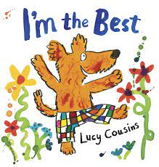  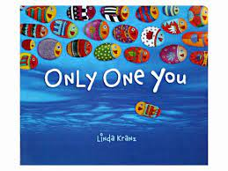 | 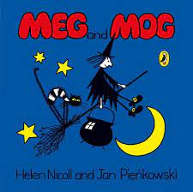  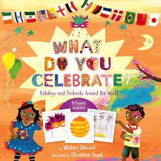 | 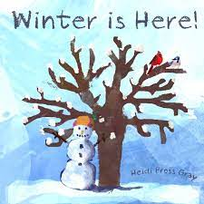  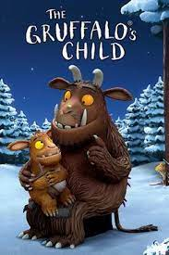 | 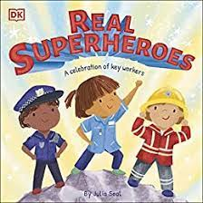  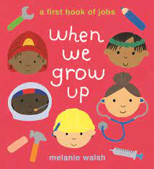 | 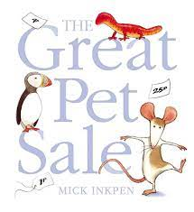  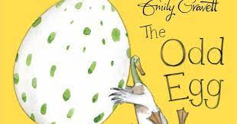 | 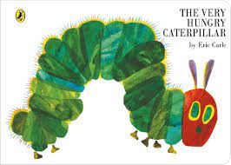  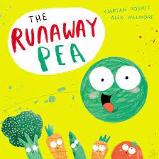
 | Engaging with new texts.  joining in with repeated refrains.  developing a love for stories and books.  developing their vocabulary linked to the topic.  name writing | Blending and segmenting cvc words.  developing and strengthening their pencil grip.  letter formation  retelling stories in the reading area using puppets. | Sequencing stories.  writing captions and labels.  guided writing to develop writing short sentences.  Using some common exception words from memory and from visual resources.  Repetition of reading familiar books to strengthen vocabulary. | Beginning to understand by asking and responding to ‘how’ and ‘why’ questions and use these to influence their critical; thinking.  Using more details and vocabulary taken from non-fiction texts.  Developing own narratives and explanations taken from real life experiences.  Writing lists  Writing speech bubbles. | Developing independent writing and reading skills.  instructional writing.  Developing use of adjectives verbally.  Writing for a purpose within areas of provision.  Beginning to use some key features of a narrative.  Gathering and using literacy resources with independence and recognition for their intended use. | Story writing.  writing sentences using a range of tricky words that are spelt correctly. Beginning to use full stops, capital letters and finger spaces without prompt.  Innovation of familiar texts.  -Using familiar texts as a model for writing own stories.  -Character description
 | Autumn 22 |  | Spring 23 |  | Summer 23
Explorers  Year 1/2 | 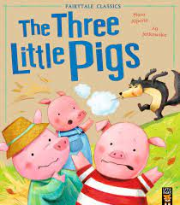  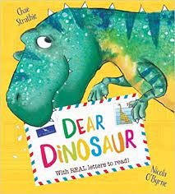  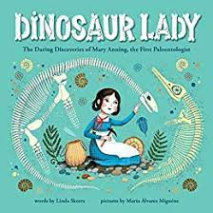  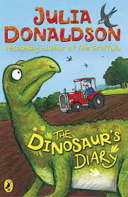 |  | 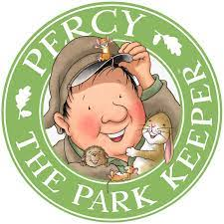  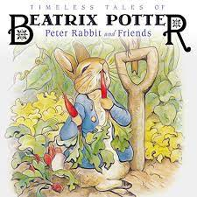  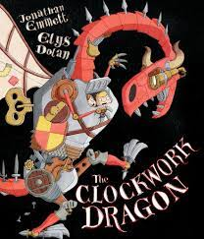  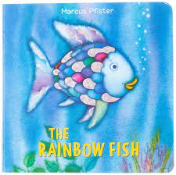 |  | 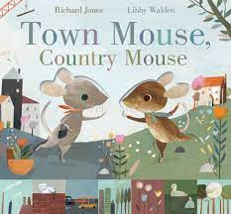  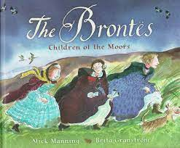  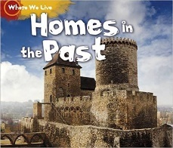
 | Familiar settings  Narrative/predicted language  Recounts  Stories by same author  Labels and captions  Diary entries  Poetry on senses |  | Narrative  Lists  Non-Chronological reports  Poetry  Letters  Character setting descriptions |  | Poetry on a theme  Newspaper reports  Narrative  Non-fiction reports  Instructions
SPaG | What is a sentence?  Nouns and verbs  Adjectives  Subject/verb identification  Full stops  Question marks  Exclamation marks |  | Replace the subject with a pronoun  Basic prepositions  Full stops  Question marks  Exclamation marks |  | Sentence types  Co-ordinating conjunctions (and, but, so, or)  Full stops  Question marks  Exclamation marks  Basic use of commas

 | Autumn 1 | Autumn 2 | Spring 1 | Spring 2 | Summer 1 | Summer 2
Discoverers  Year 3/4 | Class novel:  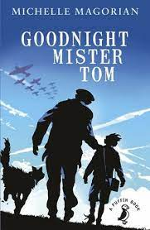  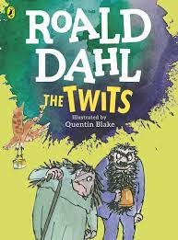 |  | 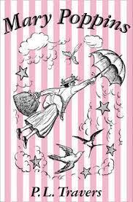  Class novel:  Plus David Walliams  book TBC |  | 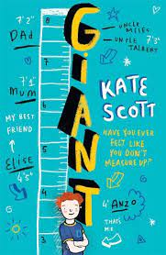  Class novel
 | 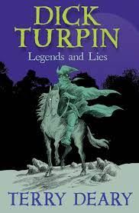 | 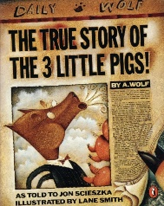 | KS2 Performance Poetry Project:  Chn will be split into groups of 6, extending across all year groups. They will study and analyse a poem related to the earth and then use it for a performance. |  | 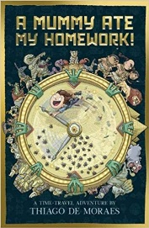 | 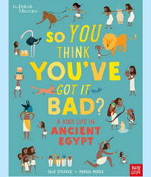
 |  |  | 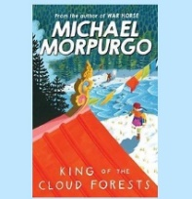 | 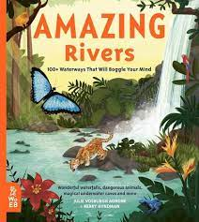
 | A balanced argument/debate with the following question as a title: Was Dick Turpin a villain? | A speech persuading a Jury that the wolf wasn’t framed.  Challenge:  A speech persuading a jury that another traditional tale character is/isn’t a villain | A diary entry from the point of view of one of the main characters | Choose their own way of presenting information about a given river. Possible options include:  Newsround style bulletin  Fact File  PowerPoint  Documentary style film | A letter from the main character in first person to someone back home. | A non-chronological report about Ancient Egypt.
SPaG | - Create and use an introduction including both sides of the argument.  - Use of a range of conjunction types, such as, on the other hand, therefore, finally.  - Use emotive language.  - Use rhetorical questions.  - Create and use a conclusion to summarise the key points. | - Use formal language and vocabulary.  - Create an appropriate introduction.  - Use technical and specific vocabulary.  - Use evidence to back up opinions  - Use present tense.  Use rhetorical questions.  Understand audience and formality required. | - Use first person.  - Use past tense.  - Use paragraphs correctly.  - Understand informality of diary.  - Portray thoughts and feelings using emotive language.  - Understand and use the correct layout. | - Use formal language (reporting style) and vocabulary.  - Use technical and specific vocabulary.  - Create and use a conclusion to summarise the key points.  - Create and use pictures, diagrams and captions. | - Understand and use level of formality correctly, for example, writing to a friend versus writing to a Member of Parliament. That is, having an awareness of the reader.  - Understand and use the correct presentation for a letter, for example, Dear and from versus Yours Faithfully or Sincerely.  - Create a relevant introduction. | - Create and use titles and sub-headings/titles.  - Use subject specific vocabulary.  - Create and use pictures, diagrams and captions.  - Use formal language.  - Create an introduction.  - Include ‘Fun facts’ and ‘Did you know?’ Have an awareness of the reader.  - Create a conclusion.

 | Autumn 1 | Autumn 2 | Spring 1 | Spring 2 | Summer 1 | Summer 2
Pioneers  Year 5/6 | 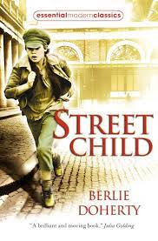  Class novel: |  | KS2 Performance Poetry Project:  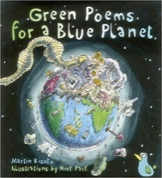  Chn will be split into groups of 6, extending across all year groups. They will study and analyse a poem related to the earth and then use it for a performance. |  | Class novel:  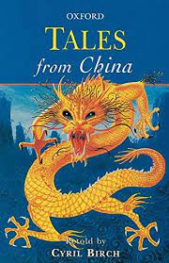
 | Driving novel for writing:  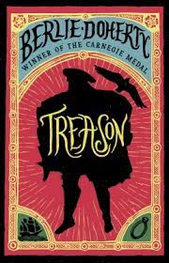 | Driving novel for writing  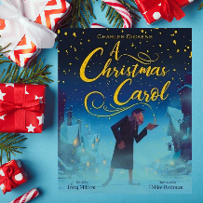 | 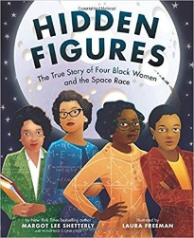  Driving novel for writing | 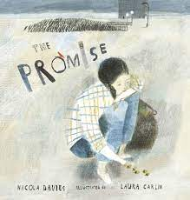  Driving novel for writing | Driving novel for writing  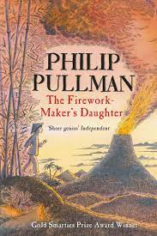 | Driving novel for writing  Short model text:  Dragon Bones by Jon Mayhew
 | Children will look at the three ways in which a narrative can be opened: description, dialogue or action. They will look at three openings about the same event, starting in different ways. They will then experiment with different ways to write in role, as Nick, about the first time he meets Will. | To produce a retelling of events of A Christmas Carol from the perspective of one of the ghosts. Children write their retelling of events. They aim to use a strong narrative voice by including clues to their character and opinions of Scrooge and the events. | • Narrative: diary entry/ letter in role as Katherine Johnson (the timeline will help here)  • Non-narrative: write a Q & A magazine article about Katherine Johnson | Children will explore the language of the text in order to create a sequel using a synonym of ‘promise’. They will be encouraged to draw upon the figurative language in the book to embed within their own narratives about nature. | Children will write a missing chapter or a character’s backstory that could be included in the Firework-Maker’s Daughter. They will draw on all learning from this unit to achieve this | Children will write their own stories that include a flashback.
SPaG | - Fronted adverbials  - Speech punctuation | Christmas Carol  - Figurative language | - Convert nouns or adjectives into verbs through the use of suffixes  - Use of relative clauses to add further information  - Indicating degrees of possibility using modal verbs and adverbs of possibility  - Use of adverbials fronted adverbials  - Use of adverbials to build cohesion within paragraphs  - Use of cohesive devices such as repetition of a word or phrase and the effective use of nouns and pronouns  - Use of the perfect form of verbs  - • Use of dashes to mark the boundary between independent clauses • How hyphens can be used to avoid ambiguity |  |  | - Homophones - noun or verb can help with spelling (e.g. advice or advise)  - Dialogue is used to convey character in narratives.

