Once Upon a Time

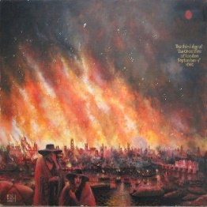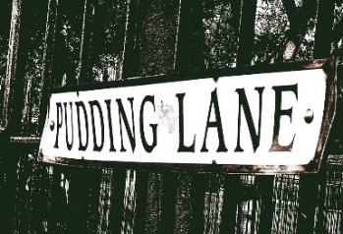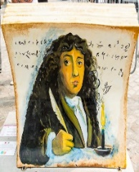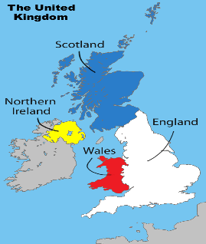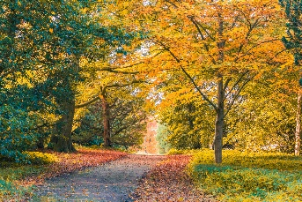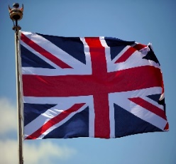
This Photo by Unknown Author is licensed under CC BY-SA
This Photo by Unknown Author is licensed under CC BY-NC
This Photo by Unknown Author is licensed under CC BY-NC-ND
This Photo by Unknown Author is licensed under CC BY-SA
History | Geography
During this unit of learning in History, the children will explore and research about The Great Fire of London an event beyond living memory that is significant nationally and how the life of Samuel Pepys, a significant individual in the past has contributed to national and international achievements  The children will learn and explore the following enquiry-led questions:  - .How did the great fire start?  - Where did it start?  - Why did it spread so quickly?  - What was it like for people in London at this time?  - How long did the fire last?  - How was it eventually put out?  - What role did King Charles 2nd play and Samuel Pepys?  - What did we learn from the fire?  - Why wasn’t there a fire service to put out the fire? | During this unit of learning in Geography, children will have a greater understanding of what the United Kingdom means and which countries belong to the United Kingdom. They will learn about the capital cities in the United Kingdom and will explore the countries’ flags and their meanings. The children will learn about the 5 oceans and continents and locate them on a world map. The children will also continue to learn about the different seasons, and in particular how the seasons change throughout the year from one to the other.  The children will learn and explore the following enquiry-led questions:  - What do you know about the United Kingdom?  - Where do you live?  - Where is Bradford in relation to the rest of the United Kingdom and the world?  - Which countries make up the United Kingdom?  - What are the capital cities of each country of the United Kingdom?  - What are the seven continents of the world?
NC Link | NC Link
- the lives of significant individuals in the past who have contributed to national and international achievements.  - events beyond living memory that are significant nationally or globally | - Locational knowledge  - name and locate the world’s seven continents and five oceans  - Human and physical geography  - identify seasonal and daily weather patterns in the United Kingdom and the location of hot and cold areas of the world in relation to the Equator and the North and South Poles  - use basic geographical vocabulary

Zoom to the moon and beyond

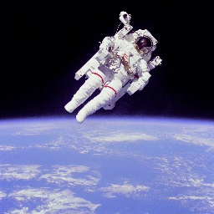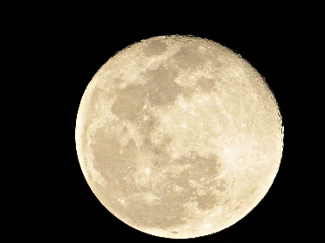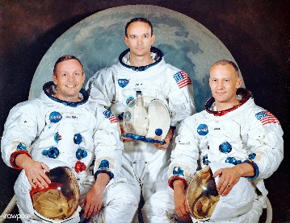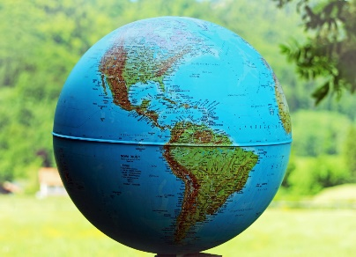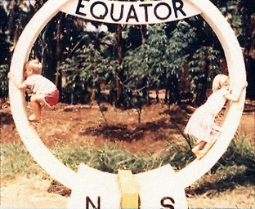
This Photo by Unknown Author is licensed under CC BY-NC-ND

During this unit of work in History children will study and research all about space and the first moon landing in 1969. They will look at the life of an astronaut and what it must have been like to go into space. They will compare and contrast 2 astronauts- Tim Peake and Neil Armstrong. They will also learn about the 3 astronauts who landed on the moon and the historical phrase spoken.  The children will learn and explore the following enquiry-led questions:  - What are the moon landings and why was it an important event globally?  - Who were the 3 astronauts who went into space and landed on the moon for the first time?  - Why do we talk about the space race and which countries were very important in this?  - What did Neil Armstrong say when he walked on the moon and why was it important?  - What were the facts about the rocket and the astronauts and when it happened?  - How has this landing developed our space knowledge and what is NASA? | During this unit of work in Geography children will study and research human and physical geography and identify seasonal and daily weather patterns in the United Kingdom and the location of hot and cold areas of the world in relation to the Equator and the North and South Poles.  The children will learn and explore the following enquiry-led questions:  -What does the world look like?  - Where are the hot countries and cold countries?  -Where is the equator?  - What does Northern and Southern hemisphere mean?  - What is the North Pole?  -What is the South Pole and where are they located on a world map?
NC Link | NC Link
- understand key features of events, choosing and using parts of stories and asking and answering questions.  - changes within living memory. Where appropriate, these should be used to reveal aspects of change in national and global life  - significant historical events and people  - create their own structured accounts, including written narratives and analyses | - Place knowledge  - understand geographical similarities and differences through studying the human and physical geography of a hot and cold country.  - use basic geographical vocabulary  - use world maps, atlases and globes to identify the equator and the Northern and Southern hemispheres  - use simple compass directions (North, South, East and West) and locational and directional language
What a wonderful world!
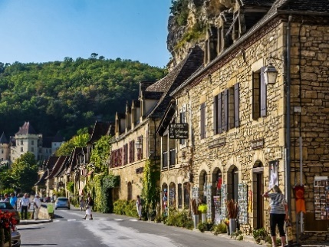
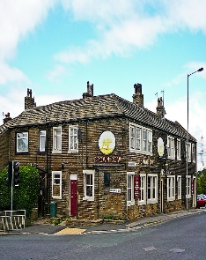
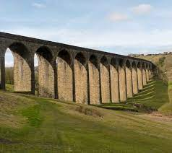
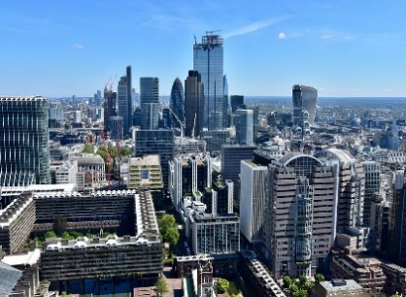
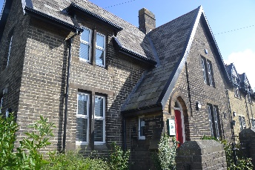
During this unit of learning in History, children will learn about their local area and the villages of Thornton, Keelham and Denholme with a focus on Thornton. They will look at significant structures and buildings in these areas and buildings past and present. They will compare old and new buildings and research the history of Thornton. They will find out about famous people who lived in Thornton and nearby localities.  The children will learn and explore the following enquiry-led questions:  - What are the towns and villages near our school called?  - Where on a map are they?  - How close to school are they?  - What significant buildings or structures are there in each area?  - Visit an area in the locality and find out about its history.  - How has Keelham or Thornton changed over the years?  - What can we find out about our own school? | During this unit of work in Geography, children will learn and understand Human Geography and Physical Geography. Children will be become familiar with the terms: city, town, village factory, farm, house, beach, cliff, coast, forest, and hill (see NC expectations and Keelham skill document.) and apply this knowledge to their own local area. The children will explore and recognise local landmarks using aerial photographs and maps. This knowledge and skills will then be transferred when comparing and contrasting Keelham to the non-European country of Botswana in particular the town of Maun. The unit will end with the children comparing and contrasting Keelham and Maun and discuss their findings with our partner school: Delta Waters International School Botswana.  The children will learn and explore the following enquiry-led questions:  - What is the difference between human and physical geography?  - What do the terms……. mean?  - Where is Maun?  - What can you find out about Maun? Where is it in the world? What physical and human geographical features can you find?  - What are the similarities and differences between Keelham and Maun in Botswana?
NC Link | NC Link
- the lives of significant individuals in the past who have contributed nationally  - significant historical events, people and places in their own locality  - events beyond living memory that are significant nationally or globally  - How areas have changed from then to now | - Place knowledge  - understand geographical similarities and differences through studying the human and physical geography of a small area of the United Kingdom, and of a small area in a contrasting non-European country  - use aerial photographs and plan perspectives to recognise landmarks and basic human and physical features; devise a simple map; and use and construct basic symbols in a key

