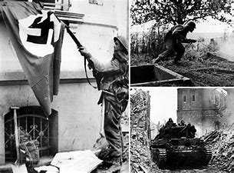
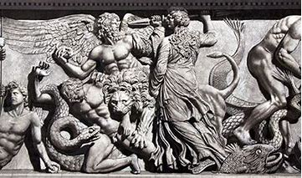
It’s All Out War!
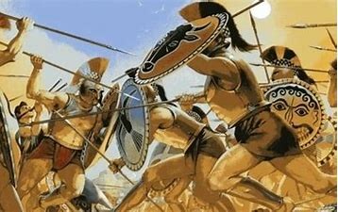
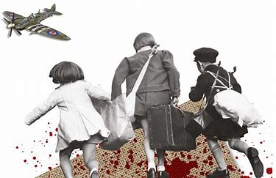

Discoverers | Pioneers
Ancient Greeks – with a focus on battles/Persians /Gods of War, The Battle of the Titans etc.  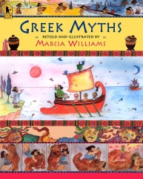  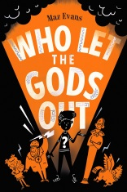 | WW1, WW2 in Europe and the Battle of Britain,  Focus texts:  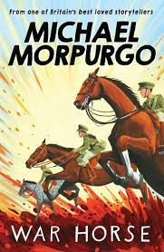  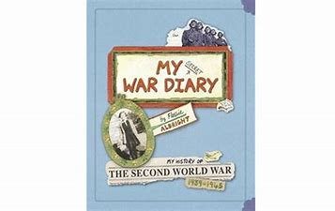
NC Link:  - Ancient Greece – a study of Greek life and achievements and their influence on the western world  - the achievements of the earliest civilizations – an overview of where and when the first civilizations appeared and a depth study | NC Link:  - a study of an aspect or theme in British history that extends pupils’ chronological knowledge beyond 1066
- Chronology  Say when the Ancient Greek people lived and order events from the time on a timeline. Examine how the Greek empire grew and locate it on a map.  - Everyday life  Learn about the everyday lives of the Greeks with a focus upon children. What would our life be like if we were a child in Ancient Greece? Compare to modern day  - Battles  Describe key facts about the Battle of Marathon and the Trojan War and answer questions to demonstrate their understanding. Look at the warfare tactics of the Greeks and how effective they were.  - Gods/Goddesses  Research Ancient Greek gods and know the features of Greek myths. Focus upon the Gods of war – use this knowledge to write our own myths.  - Greek democracy  Explain how and why the Greek Empire was so successful and be able to explain how the political system worked.  - Olympics  Understand our knowledge of the past is constructed from a range of sources e.g. Greek vases (art link??). Note connections, contrasts and trends over time e.g. How the Olympics have changed over time but how some features have remained the same.  Hold our own Olympic games?? | WW1 mini topic:  - Causes of War  - The Western Front  - The Home Front  - War is Over  WW2  - The Battle of Britain  Understand why World War 2 started, and what is meant by the ‘Phoney War’. Develop a familiarity with the location of the countries involved in the first year of World War 2. Examine some of the major events leading up to the Battle of Britain. Understand the German plans for invading Britain and the role aircraft played.  - Churchill and Key Moments of the War  Develop an understanding of who Churchill was and his significance as a leader. Gather facts from a range of sources and identify key information  - Home Front  What happened to ordinary people and children during the war? Learn about the home front, the rationing, digging for victory, ‘make do and mend’, Dad’s Army, the Land girls and the role of women during the war, the Blitz and the experience of evacuee children.  - Anne Frank and The Holocaust  This is a sensitive and age-appropriate block about the lives and deaths of Jewish people during World War 2, including prejudice, oppression and the concentration camps. Study the life of the positive and inspirational Anne Frank and create a class memorial art installation to remember the Holocaust and the Jewish people who were killed  - VE Day - End of the War in Europe  Research the events leading up to, and involved in, the end of the war. Learn about the D-Day landings, the role of the French Resistance including women in the Resistance. Learn about the surrender of countries, the Battle of Berlin and death of Hitler. Consider the Paris Peace Treaties of 1947
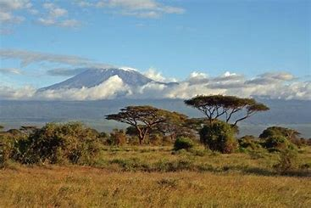
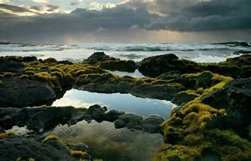
Surviving the Biomes
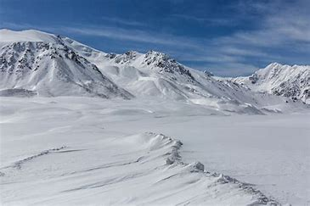
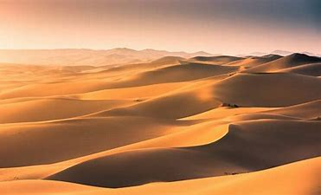

Discoverers | Pioneers
Forests and Deserts  Continent focus – North/South America  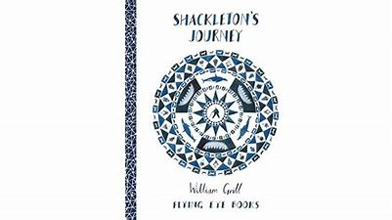  History – Tribes (indigenous), Mayans  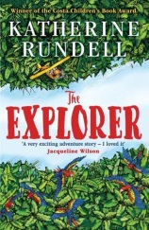  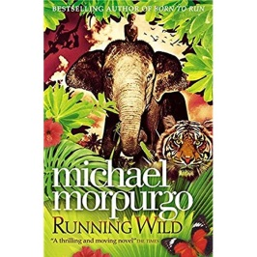  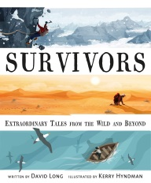 | Savannas and Tundra  Continent focus - Africa and Antarctica  History – Benin/Shackleton  Science – Evolution & Inheritance  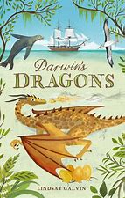  Focus texts:  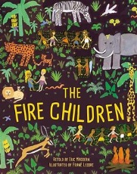
NC Link:  Human and physical geography  - ▪Describe and understand key aspects of: ▪ physical geography, including: climate zones, biomes and vegetation belts, rivers, mountains, volcanoes and earthquakes, and the water cycle  - ▪ human geography, including: types of settlement and land use, economic activity including trade links, and the distribution of natural resources including energy, food, minerals and water  Geographical skills and fieldwork  - ▪ use maps, atlases, globes and digital/computer mapping to locate countries and describe features studied  Place knowledge  - ▪ understand geographical similarities and differences through the study of human and physical geography of a region of the United Kingdom, a region in a European country, and a region within North or South America  Locational knowledge  - ▪ locate the world’s countries, using maps to focus on Europe (including the location of Russia) and North and South America, concentrating on their environmental regions, key physical and human characteristics, countries, and major cities | NC Link:  Human and physical geography  - ▪Describe and understand key aspects of: ▪ physical geography, including: climate zones, biomes and vegetation belts, rivers, mountains, volcanoes and earthquakes, and the water cycle  - ▪ human geography, including: types of settlement and land use, economic activity including trade links, and the distribution of natural resources including energy, food, minerals and water  Geographical skills and fieldwork  - ▪ use maps, atlases, globes and digital/computer mapping to locate countries and describe features studied  Locational knowledge  - ▪ locate the world’s countries, using maps to focus on Europe (including the location of Russia) and North and South America, concentrating on their environmental regions, key physical and human characteristics, countries, and major cities
World Biomes  What is a biome?  Rainforests (Amazon focus)  - To identify areas of the world containing rainforests using maps and atlases.  - To understand that rainforests are found near the equator, locate this on a map.  - To describe the weather in a tropical climate (Amazon focus)  - To name the four layers of the rainforest and describe the climate in each layer  - To understand how animals have adapted to the rainforest and which animals you can find in each layer  - To research the indigenous tribes of the Amazon rainforest and compare their way of life to ours  Deserts (North America focus: The Great Basin Desert)  - What is a desert?  - Identify areas of the world containing deserts using maps and atlases  - To describe the climate of a desert (Basin Desert focus)  - To find out which animals can be found in the desert and how they have adapted.  Mayans  - Who were the Mayans?  - Where did they live?  - Find out when Maya was first recognized by archeologists and when it came to and end and recognize that there are still living Maya people today  - Writing – find out about logograms and hieroglyphs were used and use them to write our own words, including our name.  - Discover the Copan stairway  - Explore the methods of farming  - Make a traditional Maya hot chocolate recipe  - Create a model illustrating how the Maya produced food  - Discover the childhood of the Maya and how skills were passed down generations.  - Learn about the music and foods eaten  - Research Maya fashion  - Discover the modern culture of the Maya people | World Biomes  What is a biome?  Polar regions  - To understand what the polar regions of the Arctic and Antarctica are like  - To understand the causes of the polar climate and seasons.  - To understand how animals have adapted to the polar area  - To understand how plants have adapted to the polar environment.  - To understand how the Nenets have adapted to the Arctic environment.  - Investigate the life of Ernest Shackleton  - To understand key geographical details of Shackleton’s expedition.  - To imagine being on Shackleton’s team as they prepared for life on the ice  - Savannah Biome  - Africa  - Benin  Introduction to Benin  Investigate the development of the Kingdom of Benin in context within a West African setting, and contrast it with contemporary developments in Europe. Compare the history of art in both areas. Learn about the impact that the art of Benin has had on the western world.  The Benin Kingdom  Learn about the rise and establishment of the Benin Kingdom. Consider what brought the Edo people to the rainforests of Benin and how the empire grew.  Religion  Find out about the legends of the Edo speaking people of Benin. Explore the famous creation story of Olorun and Obatala as well as other gods that were worshipped and the shrines that were built to give them offerings. Make shrines to the old gods or religious scenes of the Edo people inspired by Benin artwork.  Rulers  Find out about the Oba of Benin and the structure of government. People gave tributes to the Oba through their representative chiefs. Learn how although all the rulers were generally men, the mother of the Oba was always considered to be very important.  End of Benin  Find out about the development of the Empire of Benin after European contact in the fifteenth century and the effect it had on the area. Learn about the kingdom's decline and how it was colonised by European countries, eventually leading to its attack by the British in 1897 which destroyed Benin City and saw many of its riches taken back to Britain.
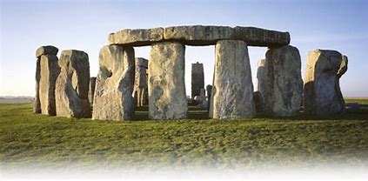
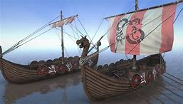
Hunters, Gatherers, Invaders & Settlers

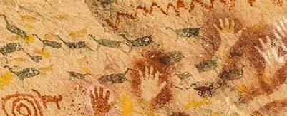
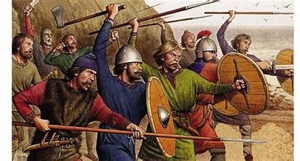

Discoverers | Pioneers
Stone Age to Iron Age  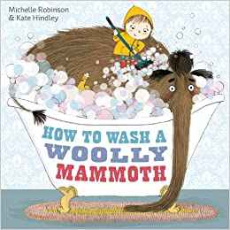  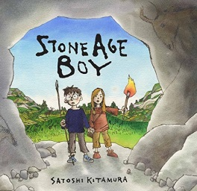 | Anglo-Saxons & Vikings  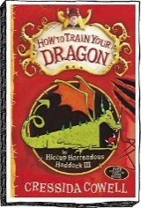  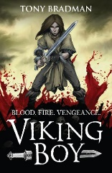  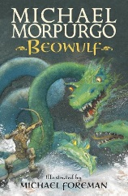  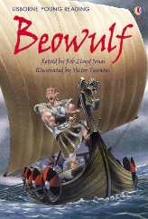
NC Link:  - changes in Britain from the Stone Age to the Iron Age  - the achievements of the earliest civilizations – an overview of where and when the first civilizations appeared and a depth study | NC Link:  - Britain’s settlement by Anglo-Saxons and Scots  - the Viking and Anglo-Saxon struggle for the Kingdom of England to the time of Edward the Confessor
Stone Age  Children will learn that prehistory is the time before written records began and that we know about this time from the sources of evidence left behind that have been studied by archaeologists.  They will learn that prehistoric times went through a series of ages, during which early Britons made huge technological advances for the time and left a lasting mark on the British landscape. Children will also explore key substantive concepts such as settlement, migration, tribe and technology. When learning about the Stone Age, children will learn how prehistoric people migrated to Britain and eventually settled here after the last ice age. They will learn about how early humans survived as hunter-gatherers, living a nomadic life and they will begin to consider the evidence that tells us this.  We will look at a range of archaeological evidence to look in more detail at the lives of prehistoric people. This includes the changes and developments that occurred in the Stone Age, the technological advances in tools, the establishment of permanent settlements like Skara Brae and the growth of agriculture.  Bronze Age  Children will recognise the end of the Stone Age and explore how metals were first used, measuring the impact of this advance. Children will investigate the building of tombs and monuments, such as the world-famous Stonehenge and consider the expertise early Britons had in building and engineering.  When learning about Skara Brae and Stonehenge, there will be opportunities for children to undertake their own independent research.  Iron Age,  We will explore the uses for this new, stronger metal (iron) and its impact on the way of life of people called Celts. We will look at how settlements changed and focus upon hillforts and why they were built.  Key Questions  How Did People Survive During the Stone Age?  What Changed For People Living in Stone Age Britain?  How Do We Know About Life in the Stone Age?  How Did Life Change in the Bronze Age?  What do we know about Britain’s Prehistoric Tombs and Monuments?  Who were the Celts and how did they make iron in the Iron Age?  Why did they build hillforts in Iron Age Britain? | Anglo-Saxons  Introduction to the Anglo-Saxons  Contextualise the Anglo-Saxon period within a timeline of Britain. Through discussion, children understand the terms 'invaders' and 'settlers' and discuss motivations for emigration. Gain historical insight into the lives of Anglo-Saxon and British people.  Invasions  Learn about the Anglo-Saxon invasions: routes, kingdoms, ancient roads, warriors and historical sources that we use to understand them. Play an invasion game, paint pictures and make a shield. Study the Bayeux Tapestry for what we can learn from it about the Anglo-Saxons and create your own narrative tapestry.  Beliefs  Learn about Anglo-Saxon beliefs. Research pagan beliefs as well as the rise of Christianity during Anglo-Saxon times. Investigate writing and find out about contemporary documents.  Kings and Laws  Learn about important Anglo-Saxon Kings, especially King Ethelbert, King Offa and King Alfred. Gain a deeper understanding of the timeline of events of the later kings. Learn about the system of law and order and the class system.  Vikings  Introduction to the Vikings  Where did the Vikings come from? Where did they invade and settle? Why did they leave Scandinavia? How do we know about them? Work on time lines, maps, completing a quiz, and creative writing exercises. Begin to appreciate why the Vikings were successful and to empathise with the people of Britain who experienced invasion.  Viking Raiders  Learn about the beliefs and weapons of the Viking warriors, the design of their longships and famous Viking leaders and explorers.  Viking Way of Life  Research Viking farm settlements. Learn about Viking traders, their routes, the items they traded and their markets  Mythology, Art and Culture  Learn about the beliefs of the Vikings, the god and goddesses, the Viking creation myth, the Norse nine worlds and Tree of Life. Find out about their writing, sagas and legacy

