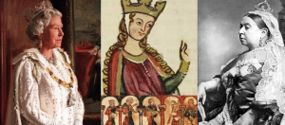
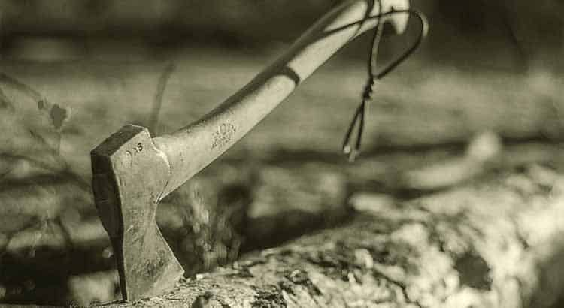
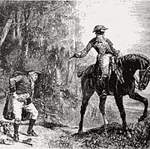
My Way or the Highway!

Discoverers  Crime and Punishment | Pioneers  The Changing Power of the Monarchs
NC links:  A study of an aspect or theme in British history that extends pupils’ chronological knowledge beyond 1066  History:  - changes in an aspect of social history, such as crime and punishment from the Anglo-Saxons to the present or leisure and entertainment in the 20th Century | NC links:  A study of an aspect or theme in British history that extends pupils’ chronological knowledge beyond 1066  History:  - the changing power of monarchs using case studies such as John, Anne and Victoria
Focus texts:  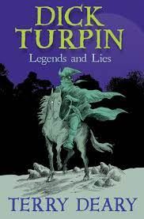 | 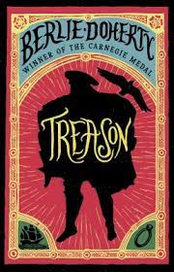  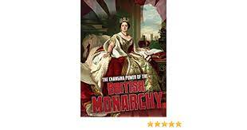  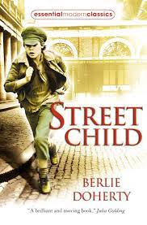  Focus texts:
Introduce children to the development of the system of courts, police and different approaches to punishment from the Anglo-Saxon times to the modern day. The topic of crime and punishment is explored sensitively through philosophical enquiry, creative writing, poetry, drama, art and design.  Children will:  - Learn about the development of the rule of law in British history from 1066 to the present day by studying this informative and creative block.  - Make a timeline of developments in crime and punishment  - Research some criminals from the past; what were they accused of and the evidence against them.  - Learn about the different kinds of criminal courts that people could face from the Anglo-Saxon times to the present day and undertake re-enactments of trials  - Learn about how the police were formed in the eighteenth century and how their job has changed over the years.  - Find out about the types of work police officers do and find out about the earliest police officers; learn about detective work, crime prevention and finally devise your own school campaign to encourage good behaviour. | Children will:  - Identify Britain’s current monarch and heir(s)  - Order significant British monarchs across time  - Provide simple definitions of ‘absolute monarchy’ and ‘constitutional monarchy’  - Identify examples of how William used his power  - Describe the impact of William’s style of monarchy on society and the Church  - Discuss the utility and reliability of sources contemporary to the time  - Identify how William’s style of monarchy is different to Elizabeth II  - Describe the reasons for Magna Carta and explain what it was  - Describe the impact the implementation of Magna Carta had on the power of the monarch  - Identify key differences between William’s and John’s power  - Explain some of the reasons that a parliament was established during Henry III’s reign Identify and describe powers that parliament took away from Henry III  - Understand why the UK was such a powerful nation in the Victorian era.  - Describe the continuing change in the power of the monarch since William I  - Describe how the abdication of Edward VIII changed the line of succession in Britain and how Parliament’s rules led to this  - Explain how Elizabeth II therefore became our monarch
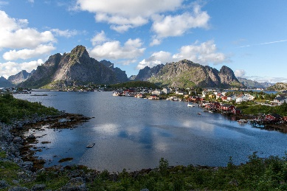
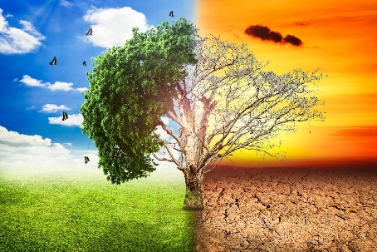
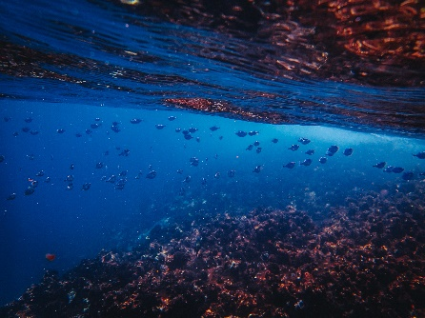
Active Planet!
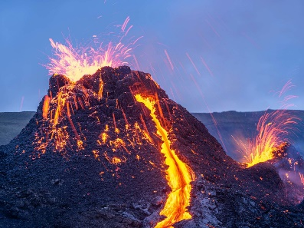

Discoverers  Mountains, Rivers and Coasts | Pioneers  Natural Disasters and Climate Change
NC links:  Geography:  - Locational knowledge:  Name and locate counties and cities of the United Kingdom, geographical regions and their identifying human and physical characteristics, key topographical features (including hills, mountains, coasts and rivers), and land-use patterns; and understand how some of these aspects have changed over time  - Human and physical geography  Physical geography, including: climate zones, biomes and vegetation belts, rivers, mountains, volcanoes and earthquakes, and the water cycle | NC links:  Geography:  - Locational knowledge:  Name and locate counties and cities of the United Kingdom, geographical regions and their identifying human and physical characteristics, key topographical features (including hills, mountains, coasts and rivers), and land-use patterns; and understand how some of these aspects have changed over time  - Human and physical geography  Physical geography, including: climate zones, biomes and vegetation belts, rivers, mountains, volcanoes and earthquakes, and the water cycle
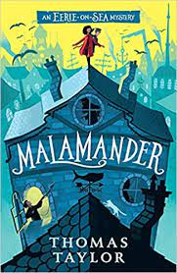  Focus texts: | 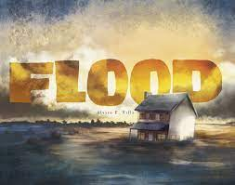  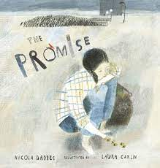  Focus texts:
In this fascinating topic, children will learn what mountains, rivers and coasts actually are, some of the forces that help create and shape these important features, and the effects they have on the world around them. They will learn about the climates, human interactions, and lifestyles shaped by the mountains, rivers and coasts of the world.  Children will:  - Learn about the formation and features of a river.  - Follow its journey to the sea and discover the role of the water cycle.  - Find out about the importance of rivers in settlements, travel and farming.  - Investigate bridges, irrigation, and the industrial use of rivers too.  - Design and make their own water wheel!  - Locate the highest peaks, identify mountain ranges, and research key facts about these.  - Journey to the Kumaon region of India and learn about the life of a Kumaon child.  - Find out about the fascinating Kumaon region and the tallest peaks of the Himalayas.  - Compare this region to their own as they develop learning. | Children will:  - Learn about the features and key aspects of earthquakes.  - Find out about the movement of tectonic plates and about seismic waves.  - Learn about life in an earthquake zone; compile and practise a class earthquake drill.  - Find out how buildings are built to withstand earthquakes and then design your own earthquake-proof structure.  - Learn about the features of volcanoes, their formation and discover how they are distributed around the world.  - Create models, artwork and ‘David Attenborough’ style commentaries.  - Understand key terms and explore how climate change is affecting people, plants and animals around the world.  - Find out how people are taking action and how they can solve issues now in school as well as thinking about how they might get involved in the future too.
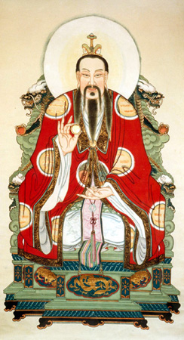
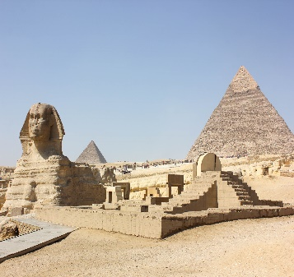
Way, Way Back in Time – Early Civilizations
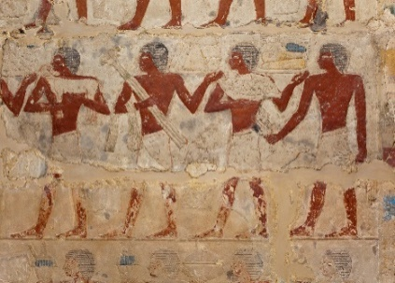
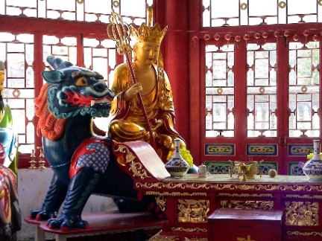

Discoverers  Ancient Egypt to the Roman Empire | Pioneers  The Shang Dynasty of Ancient China
NC links:  History:  The achievements of the earliest civilizations – an overview of where and when the first civilizations appeared and a depth study of one of the following: Ancient Sumer; The Indus Valley; Ancient Egypt; The Shang Dynasty of Ancient China  Geography:  Human geography, including: types of settlement and land use, economic activity including trade links, and the distribution of natural resources including energy, food, minerals and water  Use maps, atlases, globes and digital/computer mapping to locate countries and describe features studied | NC links:  History:  The achievements of the earliest civilizations – an overview of where and when the first civilizations appeared and a depth study of one of the following: Ancient Sumer; The Indus Valley; Ancient Egypt; The Shang Dynasty of Ancient China  Geography:  Human geography, including: types of settlement and land use, economic activity including trade links, and the distribution of natural resources including energy, food, minerals and water  Use maps, atlases, globes and digital/computer mapping to locate countries and describe features studied
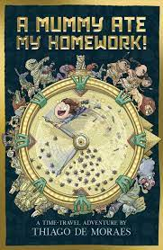  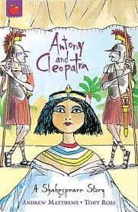  Focus texts:  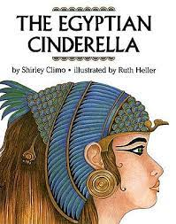 | 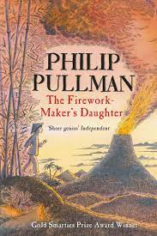  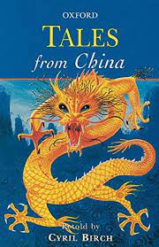  Focus texts:  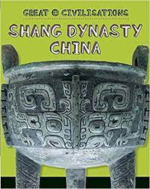
Ancient Egypt to the Roman Empire  Geography – Egypt/North Africa  Earliest Civilisations: Ancient Egyptians  Learn all about the Ancient Egyptians. Investigate the men and women who studied the kingdoms of Egypt and explore their discoveries. Look at some of the Pharaohs and the development of the pyramids, as well as the mythology that permeated Ancient Egypt. Look at the role the Nile had in allowing this civilisation to flourish and examine daily life, comparing it to our own.  Children will:  - Build knowledge of the period when the Ancient Egyptians were powerful in the world.  - Compare the Ancient Egyptian civilisation with the society, climate and terrain of Britain at the time.  - Discover how the Ancient Egyptian civilisation came to an end and also learn about the evidence of Ancient Egypt that exists in modern Egypt today.  - Find out about intrepid Egyptologists Champollion and Howard Carter and their incredible discoveries, achievements and methods.  - Learn about the mighty rulers of Ancient Egypt, their dynasties, battles and burials.  - Discover their symbols and crowns.  - Share knowledge and understanding of the pharaohs by staging an Ancient Egyptian exhibition.  - Understand important aspects of the daily life of the Ancient Egyptians; including jobs, food, and games  - Discover the myths and tales that the Ancient Egyptians told about the creation of the world and the lives of the gods and goddesses they worshipped.  - Learn about the incredible, life-giving River Nile and its impact on civilisation in Egypt. | History - The Shang Dynasty of Ancient China  Geography – In-depth study of Asia  Earliest Civilisations: Shang Dynasty  Learn all about The Shang Dynasty of Ancient China (1600-1046 BC). Discover key information about the formation of the Shang Dynasty and the kings who ruled it. Learn about everyday life, the music, cities and settlements, and the process of worship in this early civilisation. Study how the Shang developed warfare techniques, technology, and writing.  Children will:  - Find out key information about the geography of the Shang Dynasty kingdom, their kings and the timeline of their dynasty.  - Discover the farming and cookery of the Shang Dynasty. Explore farming practices, ingredients, and the importance of the silk worm in this early civilisation.  - Learn how Chinese writing works and investigate Shang texts and calendars  - Investigate the Shang bronze manufacturing process and the amazing Shang bronze vessels  - Learn about the Shang army and generals as you investigate the Battle of Muye and the rise and fall of the Shang.  - Learn about the Shang beliefs regarding death, burial rituals, divining the future, folk religion and ancestor worship. Learn about the tomb of Fu Hao, leader and priestess and create your own time capsule.  - Research the cities and societies of this dynasty, as well as the lives and roles of the people.

