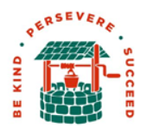 | Autumn |  | Spring |  | Summer
 | See long term writing plan below |  | See long term writing plan below |  | See long term writing plan below
White Rose Maths | Year 5  Place value  Addition and subtraction  Multiplication and division  Fraction A | Year 6  Place value  Four Operations  Fractions A  Fractions B | Year 5  Multiplication and division  Fractions B  Decimals and percentages  Perimeter and Area  Statistics | Year 6  Ratio  Algebra  Decimals  Fractions, decimals and percentages  Area, perimeter and  volume  Statistics | Year 5  Shape  Position and direction Converting units | Year 6  Shape  Position and direction Converting units
 | Autumn 1  Living Things  Classification | Autumn 2  Interleaving curriculum trial  WW2 Science related Investigations | Spring  Evolution and Inheritance |  | Summer  Scientists and Inventors
 | It’s All Out War! |  | Surviving the Biomes |  | Hunters, Gatherers, Invaders & Settlers
 | World War One and Two  (See KS2 humanities long term planning Cycle A for more detail) |  | Tundra’s – Arctic & Antarctic and the African savannahs  (See KS2 humanities long term planning Cycle A for more detail) |  | Anglo-Saxons and Vikings  (See KS2 humanities long term planning Cycle A for more detail)
 | World War sculptures |  | TBC with SH |  | Building and designing a Viking longboat
 | To research Picasso and pick out key pieces of information.  To be able to share this information with the rest of the class. To put this information into an interesting format in their sketchbooks.  To make sketches of parts of the artwork Guernica.  To work in monochrome, and know what this term means.  To keep to a scale that works with others images.  To work as a team towards one final piece.  To cut details such as eyes also from papers, and collage them together.  To contribute to a class discussion on war art.  To work as a team to explore creative sculptural ideas around a given word.  To choose materials to work in that suit the sculpture and help convey its message.  To work well as part of a team, sharing tasks.  To be able to discuss their finished piece and convey its message |  | TBC with SH |  | TBC with SH
 | Health and Wellbeing  - What affects mental health and ways to take care of it; managing change, loss and bereavement; managing time online.  - Keeping personal information safe; regulations and choices; drug use and the law; the media  Increasing independence and managing transition |  | Relationships  - Attraction to others; romantic relationships; civil partnerships and marriage  - Recognising and managing pressure; consent in different situations  - Expressing opinions and respecting other points of view; including discussing topical issues |  | Living in the wider world  - Valuing diversity; challenging discrimination and stereotypes  - Evaluating media sources; sharing things online  Influences and attitudes to money; financial risks
 | Values and Beliefs?  ____________________________________________ KS2 Christmas Unit: Why do Christians celebrate Christmas?  Key themes:  Y5 - Epiphany (Gifts and Gift bringers)  Y6 - The Gospel Accounts (Messages and Messengers) |  | What do Christians believe about Jesus’s death and resurrection?  ____________________________________________ KS2 Easter Unit: What makes Easter important to Christians? Key themes:  Y5 – Victory  Y6 – Who was Jesus? |  | Why are some journeys and places special?
Autumn 1
Book | Purpose / Genre | Talk for Writing (if applicable; 1 unit per term) | What the children will write: |  | Main Grammar & Punctuation Focus
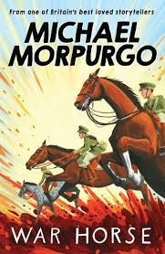 | Writing to entertain:  Short narrative |  | Children to write their own short story based on War Horse from the point of view of a horse in battle.
Autumn 2
Book | Purpose / Genre | Talk for Writing (if applicable; 1 unit per term) |  | What the children will write: | Main Grammar & Punctuation Focus
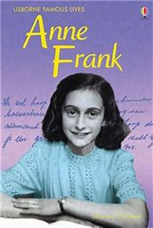 | Writing to inform:  Biography  Writing to persuade:  Persuasive Speech |  |  | Chn to write a short biography based on the life of Anne Frank  Children to write a speech/campaign standing up for the rights of Jews.
English Long-term plan
Spring 1
Book | Purpose / Genre | Talk for Writing (if applicable; 1 unit per term) | What the children will write: |  | Main Grammar & Punctuation Focus
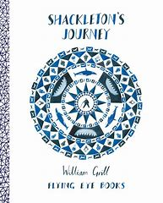 | Writing to inform:  Diary  Writing to entertain:  Descriptive writing |  | Children to write a diary entry in role as Ernest Shackleton or another main character from the story  Children to write a descriptive piece about a specific event in the text – e.g. the storm sequence
Spring 2
Book | Purpose / Genre | Talk for Writing (if applicable; 1 unit per term) |  | What the children will write: | Main Grammar & Punctuation Focus
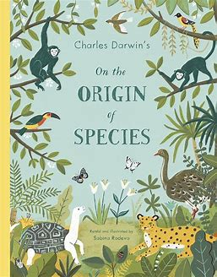 | Writing to inform:  Informational Text  Writing to persuade:  Persuasive Text |  |  | Write an information text about one of the animals of the Galapagos islands.  Write a persuasive guide inviting people to visit the Galapagos islands

Summer 1
Book | Purpose / Genre | Talk for Writing (if applicable; 1 unit per term) | What the children will write: |  | Main Grammar & Punctuation Focus
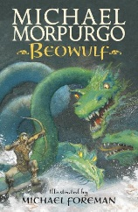 | Writing to inform:  Newspaper article  Biographies |  | Children will write a newspaper article about the killing of Grendel by Beowulf.  Children will collect information about Beowulf to write his biography.
Summer 2
Book | Purpose / Genre | Talk for Writing (if applicable; 1 unit per term) |  | What the children will write: | Main Grammar & Punctuation Focus
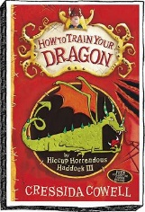 | Writing to entertain:  1st person narrative  Writing to inform:  Non-chronological report |  |  | Children will re-write part of chapter 2 in the first person, from the perspective of another character.  Children will create a non-chronological report about their own dragon.

