Pupil Premium Strategy

2021-24

Keelham Primary School

Pupil premium strategy statement

This statement details our school’s use of pupil premium (and recovery premium for the 2021 to 2022 academic year) funding to help improve the attainment of our disadvantaged pupils.

It outlines our pupil premium strategy, how we intend to spend the funding in this academic year and the effect that last year’s spending of pupil premium had within our school.

School overview
Detail | Data
School name | Keelham Primary School
Number of pupils in school | 116
Proportion (%) of pupil premium eligible pupils | 17.2%
Academic year/years that our current pupil premium strategy plan covers (3 year plans are recommended) | 2021-22, 2022-23, 2023-24
Date this statement was published | 01 September 2021
Date on which it will be reviewed | 01 September 2023
Statement authorised by | Robert Hunter
Pupil premium lead | Robert Hunter
Governor / Trustee lead | Committee C

Funding overview

Detail | Amount
Pupil premium funding allocation this academic year | £24,481
Recovery premium funding allocation this academic year | £1,166
Pupil premium funding carried forward from previous years (enter £0 if not applicable) | £0
Total budget for this academic year  If your school is an academy in a trust that pools this funding, state the amount available to your school this academic year | £25,647

Part A: Pupil premium strategy plan

Statement of intent
We organise teaching and learning at Keelham in order to meet the needs of all children in the best way. We want our children to be:
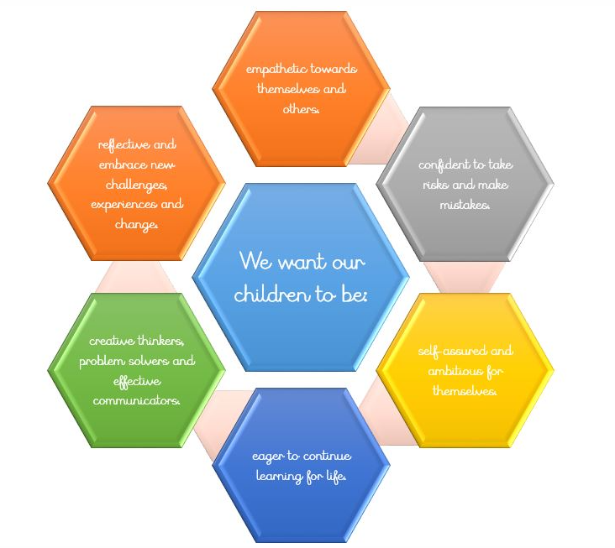
We ensure that appropriate provision is made for children who belong to vulnerable groups and that socially disadvantaged children have their needs adequately assessed and met.
We recognise that not all children who receive pupil premium will be socially disadvantaged and we recognise that not all children that are disadvantaged will be in receipt of Pupil premium money.

Challenges

This details the key challenges to achievement that we have identified among our disadvantaged pupils.
Challenge number | Detail of challenge
1 | The COVID-19 pandemic has had a negative impact on their development of basic reading skills. reading fluency and exposure to high quality texts.
2 | Some pupils on entry have speech, communication and language needs.
3 | Pupils’ present with emotional and social needs. This could affect the rate of progress they make academically.
4 | Poor attendance of some children identified as disadvantaged.
5 | Pupils in upper KS2 struggle to retain the fundamentals of mathematics.

Intended outcomes
This explains the outcomes we are aiming for by the end of our current strategy plan, and how we will measure whether they have been achieved.
Intended outcome | Success criteria
For all disadvantaged pupils in school to make or exceed nationally expected progress rates in reading. | Aim Target Target date  Progress in Reading Achieve better than national average progress scores in KS2 Reading (0) July 24  Progress in Writing Achieve better than national average progress scores in KS2 Writing (0) July 24  Progress in Mathematics Achieve better than national average progress scores in KS2 Writing (0) July 24  Phonics Achieve national average expected standard in PSC July 24  Other Ensure disadvantaged pupils’ attendance is above 95% July 24
To narrow the attainment gap between disadvantaged and non-disadvantaged pupils in writing.

Activity in this academic year
This details how we intend to spend our pupil premium (and recovery premium funding) this academic year to address the challenges listed above.

Teaching (for example, CPD, recruitment and retention)

Activity | Evidence that supports this approach | Challenge number(s) addressed
Purchase of standardised diagnostic assessments from NFER for use from September 2023  Training for staff to ensure assessments are interpreted and administered correctly. | Standardised tests can provide reliable insights into the specific strengths and weaknesses of each pupil to help ensure they receive the correct additional support through interventions or teacher instruction: | 1, 2 and 5
Observe and share practice through school and engage in further research and support collaborative conversations regarding the effectiveness of feedback | Feedback | EEF (educationendowmentfoundation.org.uk) | 1, 2 and 5
To upskill staff with appropriate approaches and pedagogy to teach early reading effectively. | Teaching assistants can provide a large positive impact on learner outcomes  Phonics | EEF (educationendowmentfoundation.org.uk) | 1, 2
Reading fluency interventions focus on the teaching of targeted reading fluency. | On average, oral language approaches have a high impact on pupil outcomes of 6 months’ additional progress.  Reciprocal Reading | EEF (educationendowmentfoundation.org.uk)  Reading comprehension strategies are high impact on average (+6 months). Alongside phonics it is a crucial component of early reading instruction.  Oral language interventions | EEF (educationendowmentfoundation.org.uk)  Reading comprehension strategies | EEF (educationendowmentfoundation.org.uk) | 1
To providing a breadth of experiences to enhance pupil’s cultural capital. Skilled teachers to deliver art, music, ICT and French to learners in KS1 and 2. | Arts participation approaches can have a positive impact on academic outcomes in other areas of the curriculum.  Arts participation | EEF (educationendowmentfoundation.org.uk) | 1,2 3, 4 and 5

 | Cost
Professionals teaching Music, Computing and MFL | £10,925
Professional teaching of Art | £3,800
NFER Materials | £1,500
 | £16,225
Targeted academic support (for example, tutoring, one-to-one support structured interventions)
Budgeted cost: £ Activity | Evidence that supports this approach | Challenge number(s) addressed
Identified pupils receive 3x weekly maths intervention additional to QFT mathematics session led by Class Teacher and HLTA (Impact assessed after 6 weeks) | Small group tuition has an average impact of four months’ additional progress over the course of a year.  Small group tuition | EEF (educationendowmentfoundation.org.uk)  Teaching assistants can provide a large positive impact on learner outcomes  Teaching Assistant Interventions | EEF (educationendowmentfoundation.org.uk) | 5
Reading Fluency Intervention for targeted pupils led by KS2 lead. | On average, oral language approaches have a high impact on pupil outcomes of 6 months’ additional progress.  Reading comprehension strategies are high impact on average (+6 months). Alongside phonics it is a crucial component of early reading instruction.  Oral language interventions | EEF (educationendowmentfoundation.org.uk)  Reading comprehension strategies | EEF (educationendowmentfoundation.org.uk) | 1
Children identified as vulnerable readers are heard reading daily. | On average, oral language approaches have a high impact on pupil outcomes of 6 months’ additional progress.  Oral language interventions | EEF (educationendowmentfoundation.org.uk) | 1
Identified pupils receive 3x weekly phonics intervention additional to QFT phonics session led by Phonics Champion in EYFS/KS1 and KS2. (Impact assessed after 6 weeks) | Phonics approaches have a strong evidence base that indicates a positive impact on the accuracy of word reading (though not necessarily comprehension), particularly for disadvantaged pupils:  Phonics | EEF (educationendowmentfoundation.org.uk) | 1, 2
The school environment encourages a love of reading and encourages children to read through ‘Yearn to Learn’ and ‘Love to Read’ texts throughout the term. |  | 1, 2, 3 and 4

 | Cost
Phonics Champion | £4,689.05
Additional materials to support a love to read | £2,300
Additional materials to support Phonics intervention | £2,000
 | £8,989.05

Wider strategies (for example, related to attendance, behaviour, wellbeing)
Activity | Evidence that supports this approach | Challenge number(s) addressed
Work with families who require support to engage with school and improve overall attendance of vulnerable children. | Parental engagement has a positive impact on average of 4 months’ additional progress.  Parental engagement | EEF (educationendowmentfoundation.org.uk) | 3,4 and 5

Total budgeted cost: £
 | Cost
Teaching | £16,225
Targeted academic support | £8,989.05
Wider strategies
 | £25,212

Part B: Review of outcomes in the previous academic year

Pupil premium strategy outcomes
This details the impact that our pupil premium activity had on pupils in the 2022 to 2023 academic year.
Below is a breakdown and analysis of the summative data from disadvantaged pupils collected from assessments undertaken at the end of KS2 for the academic year of 2022-23:
Attainment and Progress:
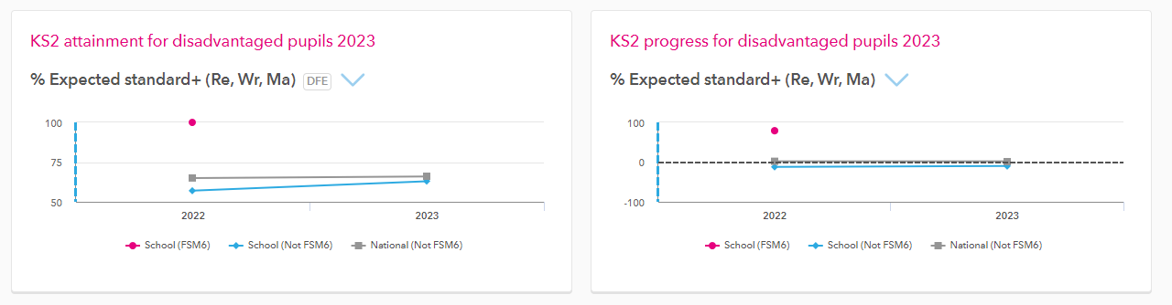

Attainment and Progress group analysis:
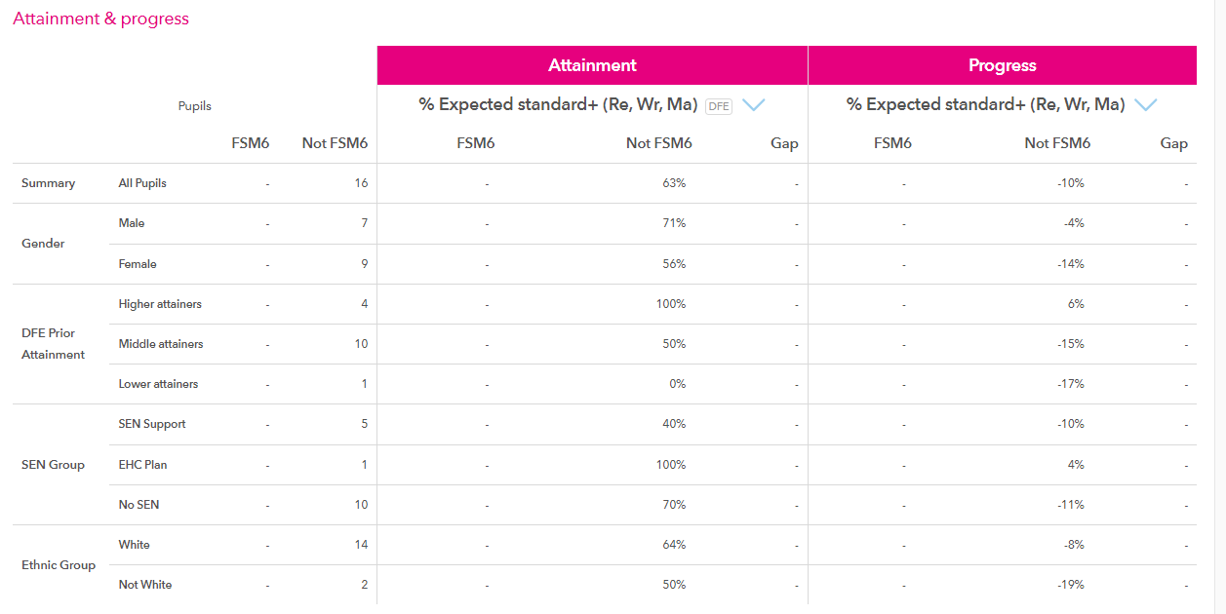

Attendance Statistics 2022 -23
Attendance of Pupil Premium Pupils

Whole School | Present R/C: Marks | Auth. Absent R/C: Marks | Unauth. Absent R/C: Marks
All Students | 93.81% | 5.61% | 0.58%

Externally provided programmes
Please include the names of any non-DfE programmes that you purchased in the previous academic year. This will help the Department for Education identify which ones are popular in England
Programme | Provider
Spelling Shed | EdShed
TT Rockstars | Maths Circle LTD
Letter Join Handwriting | Green and Tempest LTD

